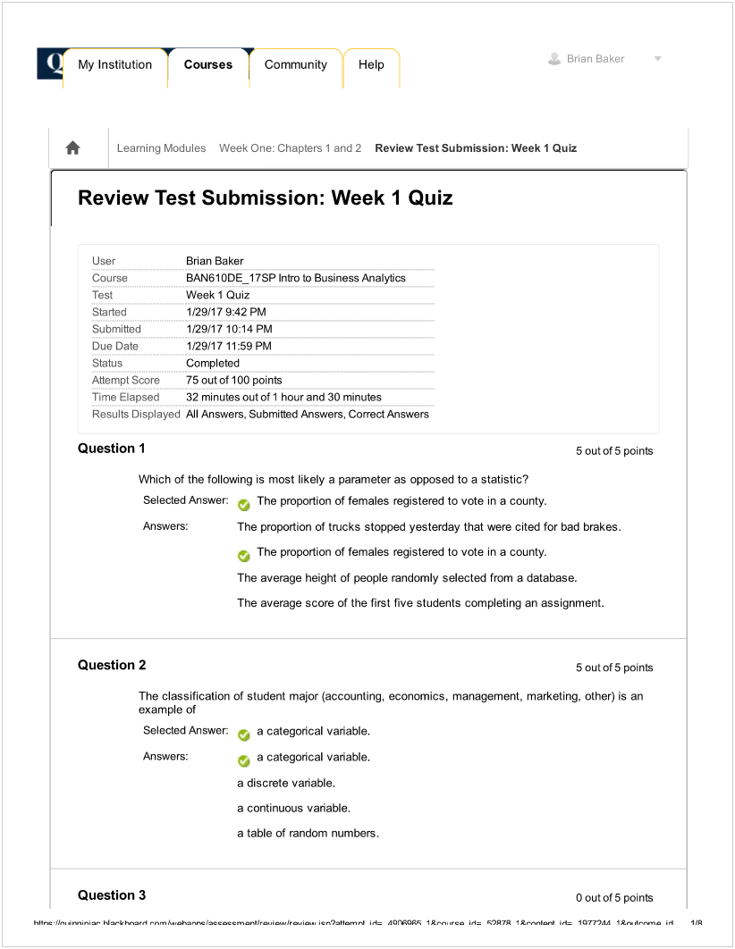

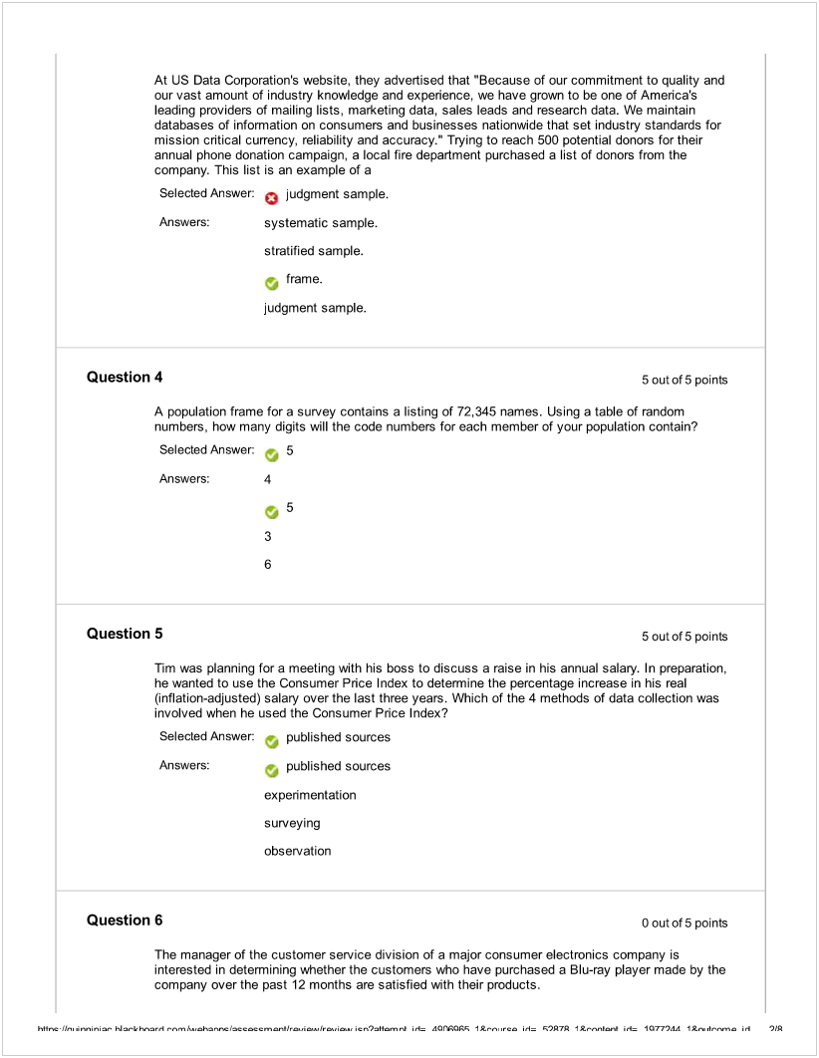

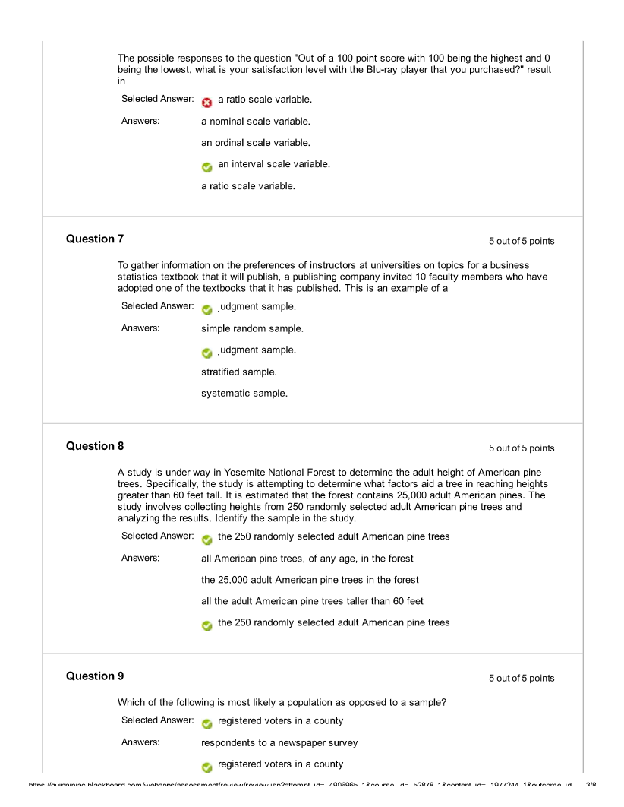

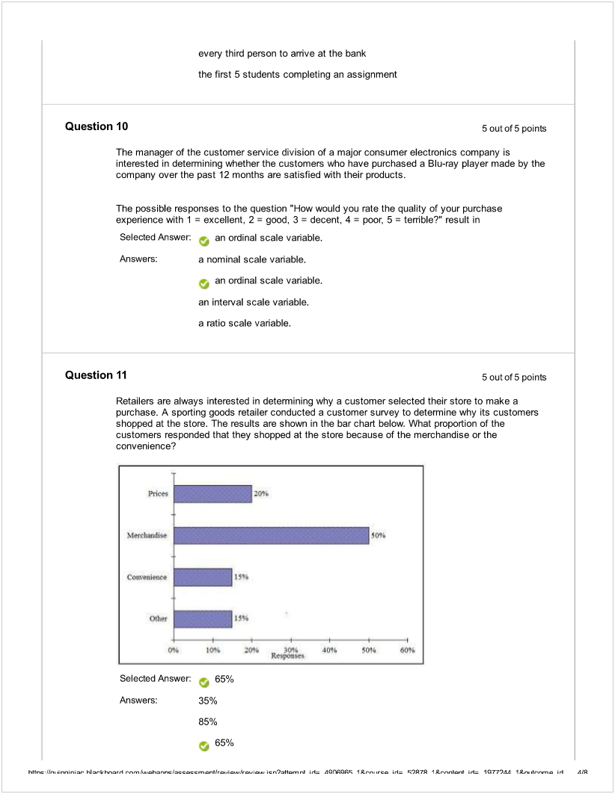

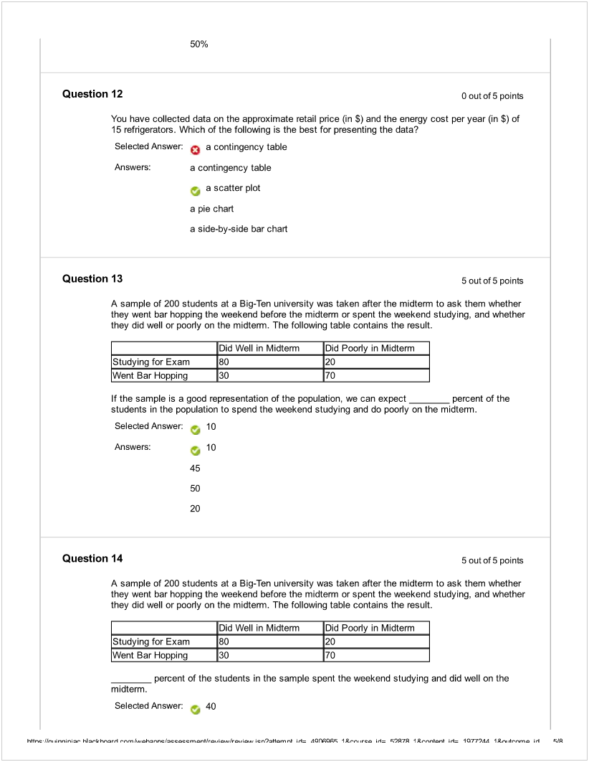

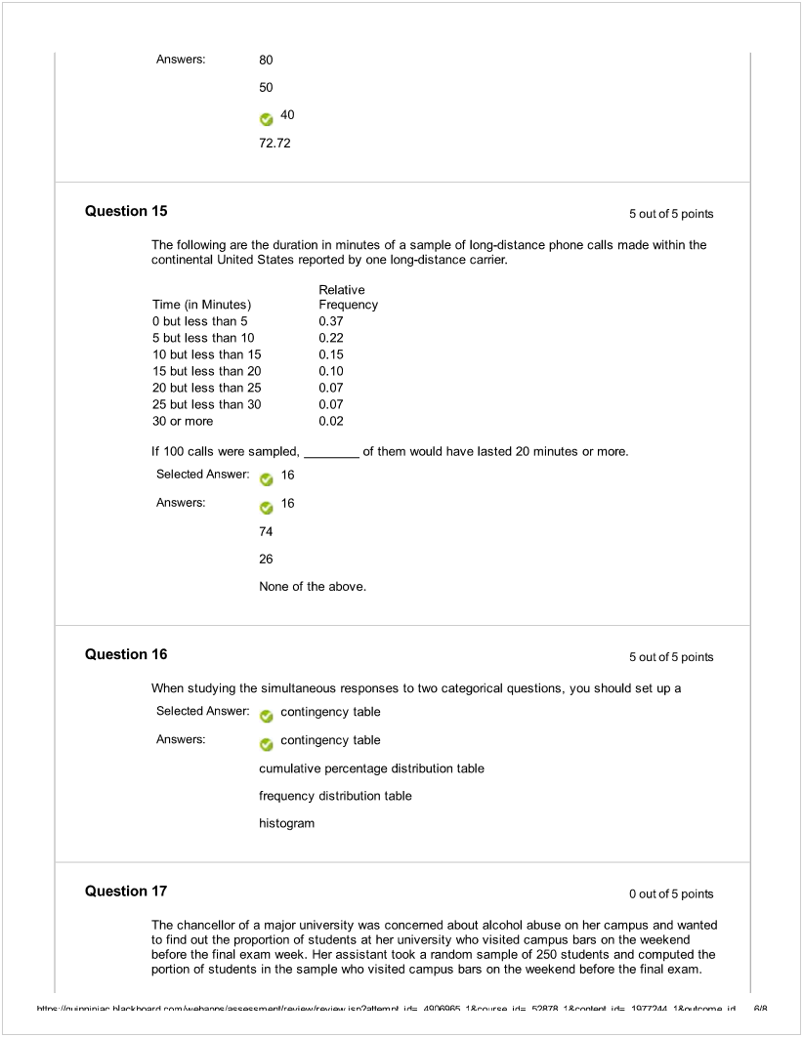

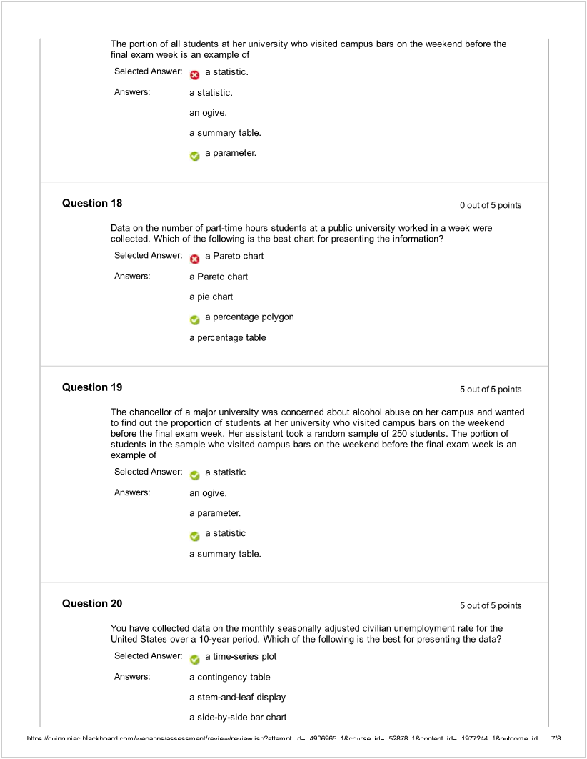

|  |  |  |  |
| --- | --- | --- | --- |
|  |  |  |  |
|  | Machine generated alternative text: a time-series plot Thursday. March 9.2017 5:04:33 PM EST [ 4 0K h+Ik,.r.nin. Ñ.-kh.nl   cn),Kn,Ñ i, AOÇOÇ trc  Ç97fi 1L,nb i4 1Q7744 1*roh’,.n, .,l lP |  |  |
|  |  | Machine generated alternative text: My Institution Courses Community Help ¿ Brian Baker A Learning Modules Week One: Chapters 1 and 2 Review Test Submission: Week I Quiz User Course Test Started Submitted Due Date Status Attempt Score Time Elapsed Results Displayed Question I Brian Baker BAN61ODE_17SP Intro to Business Analytics Week 1 Quiz 1129117 10:27PM 1/29/17 10:33PM 1129117 11:59 PM Completed 95 out of 100 points 5 minutes out of 1 hour and 30 minutes All Answers. Submitted Answers, Correct Answers 5 out of 5 points Which of the following scenarios will yield a nonprobability sample? Selected - Items or individuals are chosen without regard to their probability of occurrence. Answer: Answers: The subjects of the sample are chosen on the basis of known probability. Decide on a sample size, n; divide the frame of N individuals into groups of k individuals where k = N/n; randomly select one individual from the first group; select every kth individual thereafter. - Items or individuals are chosen without regard to their probability of occurrence. Every individual or item from the frame has an equal chance of being selected. Selection may be with replacement or without replacement. Question 2 5 out of 5 points To demonstrate a sampling method, the instructor in a class picked the first 5 students sitting in the last row of the class. This is an example of a Selected Answer convenience sample. Answers: simple random sample. systematic sample. stratified sample. -, convenience sample. Review Test Submission: Week I Quiz h+$r,c-Ik,,  Ñkh..,,,nl cn),Kn,nb i, AOfl7lAfl  rc l 97fi 1*,,nb i4 1Q7744 1*roh’,,n, .l 1?P |
|  |  |  |
|  | Machine generated alternative text: My Institution Courses Community Help ¿ Brian Baker A Learning Modules Week One: Chapters 1 and 2 Review Test Submission: Week I Quiz User Course Test Started Submitted Due Date Status Attempt Score Time Elapsed Brian Baker BAN61ODE_17SP Intro to Business Analytics Week 1 Quiz 1129117 8:45 PM 1/29/179:31 PM 1/29/17 11:59 PM Completed 95 out of 100 points 45 minutes out of 1 hour and 30 minutes Results Displayed All Answers. Submitted Answers, Correct Answers Question I 5 out of 5 points The manager of the customer service division of a major consumer electronics company is interested in determining whether the customers who have purchased a Blu-ray player made by the company over the past 12 months are satisfied with their products. The manager decides to ask a sample of customers, who have bought a Blu-ray player made by the company and filed a complaint over the past year. to fill in a survey about whether they are satisfied with the product. This method will most likely suffer from Selected Answer: - coverage error. Answers: non-probability sampling. coverage error. measurement error. nonresponse error. Question 2 5 outof5 points The manager of the customer service division of a major consumer electronics company is interested in determining whether the customers who have purchased a Blu-ray player made by the company over the past 12 months are satisfied with their products. The possible responses to the question What is your annual income rounded to the nearest thousands?” result in Selected Answer: - a ratio scale vanable. Review Test Submission: Week I Quiz h+$rcIk.,.r.nin. Ñ,-kh.-,,,nl m   c,),Kn,nb i, AOÇÇ trc  Ç97fi 1L,nb i4 1Q7744 1*r,.d,.,.n, .,l 1?P  Machine generated alternative text: Answers: a nominal scale variable. an ordinal scale variable. an interval scale variable, - a ratio scale vaflable, Question 3 5outof5poinls The manager of the customer service division of a major consumer electronics company is interested in determining whether the customers wto have purchased a Blu-ray player made by the company over the past 12 months are satisfied with their products. The possible responses to the question How many Blu-ray players made by other manufacturers have you used?” result in Selected Answer - a ratio scale variable, Answers: a nominal scale variable. an ordinal scale variable. an interval scale variable. a ratio scale variable. Question 4 5outof5points Which of the following yields a cluster sample? Selected Answer: All students in a class are divided into groups according to the rows that they are seated. One of the groups is randomly selected. Answers: All students in a class are grouped according to their gender. A random sample of 8 is selected from the males and a separate random sample of 7 is selected from the females. The best 15 students, according to the opinion of the instructor, in a class are selected. All students in a class are divided into groups of 15. One student is randomly chosen from the 1st group, the remaining observations are every 15th student thereafter. -) All students in a class are divided into groups according to the rows that they are seated. One of the groups is randomly selected. Question 5 5 out of 5 points To find out the potential impact of a new zoning law on a neighborhood, the legislators conduct a focus group interview by inviting the members of the housing owners association of that neighborhood. This is an example of a Selected Answer: - judgment sample. h+$r,c-Iku..’.,in.- Ñ.-kkn  cn),Kn,nb i, AOÇÇ’ ‘tt,rc  Ç97fi 1*,,nb i.4 1Q7744 1*r,oh’.,.n, .,l )?R  Machine generated alternative text: Answers: systematic sample. judgment sample. cluster sample. simple random sample. Question 6 5outof5points A summary measure that is computed to describe a characteristic of an entire population ¡s called Selected Answer - a parameter. Answers: an ordered array. a statistic. a parameter. a summary table. Question 7 5outof5poinls The chancellor of a major university was concerned about alcohol abuse on her campus and wanted to find out the proportion of students at her university who visited campus bars on the weekend before the final exam week. Her assistant took a random sample of 250 students. The answer on ‘whether you visited campus bars on the weekend before the final exam week” from students in the sample is an example of Selected Answer:  a categorical vaflable. Answers: -, a categorical variable. a discrete variable. a continuous variable. a table of random numbers. Question 8 5 out of 5 points Which of the following sampling methods is a probability sample? Selected Answer  stratified sample Answers: quota sample convenience sample stratified sample judgment sample Question 9 5outof5points Ñ kkw,n  JI  cn),Kn,nb i, AO( tt  l 97fi 1*,,nb i.4 1Q744 1*r,oh.,,.,, •,  Machine generated alternative text: Which of the following sampling methods will more likely be susceptible to ethical violation when used to form conclusions about the entire population? Selected Answer:  convenience sample Answers: cluster sample - convenience sample simple random sample systematic sample Question 10 5outof5points Fora population frame containing N= 1,007 individuals, what code number should you assign to the first person on the list in order to use a table of random numbers? Selected Answer -, 0001 Answers: -‚ 0001 01 o Question 11 5outof5points A sample of 200 students at a Big-Ten university was taken after the midterm to ask them whether they went bar hopping the weekend before the midterm or spent the weekend studying. and whether they did well or poorly on the midterm. The following table contains the result. Did Well in Midterm Did Poorly in Midterm Study ng for Exam 80 20 Went Bar Hopping 30 70 If the sample is a good representation of the population, we can expect ________ percent of those who spent the weekend studying to do poody on the midterm. Selected Answer -‚ 20 Answers: 10 45 20 50 Question 12 Ooutof5 points A survey was conducted to determine how people rated the quality of programming available on television. Respondents were asked to rate the overall quality from O (no quality at all) to 100 h+$rcIk,,.r..,in. Ñkkn t m.h2nr,cí,ccoccm n  cn),Kn,nb i, AO( tt,n,rc l 97fi 1*,nnb i.4 1Q744 1*n.d.,.,, .,l AlP  Machine generated alternative text: (extremely good quality). The stem-and-leaf display of the data is shown below Stem Leaves 3 24 4 5 6 7 01 8 9 2 Question 13 Question 14 Question 15 5 out of 5 points You have collected data on the monthly seasonally adjusted civilian unemployment rate for the United States over a 10-year peñad. Which of the fdlowing is the best for presenting the data? Selected Answer a time-series plot Answers: a time-series plot a contingency table a side-by-side bar chart a stem-and-leaf display 5 out of 5 points You have collected information on the market share of 5 different search engines used by U.S. Internet users in a particular quarter. Which of the following is the best for presenting the information? Selected Answer Answers: -, apiechart apiechart a stem-and-leaf display a contingency table a histogram 5 out of 5 points 03478999 0112345 12566 What percentage of the respondents rated overall television quality with a rating of 50 or below? Selected Answer o 40 Answers: 56 ‚44 11 40 h+Ik,.r.nin Ñkh.nl    i, AOÇÇ ‘trc l )7 1L,nb i4 1Q7744 IL.’...h.nm. .,l ÇÌP  Machine generated alternative text: Time (in Minutes) O but less than 5 5 but less than 10 10 but less than 15 15 but less than 20 20 but less than 25 25 but less than 30 30 or more Relative Frequency 0.37 0.22 0.15 0.10 0.07 0.07 0.02 Question 16 5outof5 points Every spring semester, the School ot l3usiness coordinates a luncheon with local business leaders for graduating seniors, their families, and friends. Corporate sponsorship pays for the lunches of each of the seniors, but students have to purchase tickets to cover the cost of lunches served to guests they bring with them. The following histogram repoesents the attendance at the senior luncheon, where X is the number of guests each graduating senior invited to the luncheon and fis the number of graduating seniors in each category. If all the tickets purchased were used, how many guests attended the luncheon? Selected Answer: -, 388 Answers: 4 The following are the duration in minutes of a sample of long-distance phone calls made within the continental United States reported by one long-distance carrier. If 10 calls lasted 30 minutes or more, how many calls lasted less than 5 minutes? Selected Answer 185 Answers: 500 185 10 295 h+$r,cIk,,  Ñkh.nl cn),Kn,nb i, AOÇÇ  rc l 97fi 1*,nb i4 1Q7744 1*r,..h’.nm. .,l 1P  Machine generated alternative text: 275 388 152 Question 17 5outof5points The width of each bar in a histogram corresponds to the Selected Answer: - differences between the boundaries of the class. Answers: number of observations in each class. midpoint of each class. percentage of observations in each class. -, differences between the boundaries of the class. Question 18 5outof5points A summary measure that is computed to describe a characteristic of an entire population is called Selected Answer a parameter. Answers: a summary table. - a parameter. a statistic. an ordered array. Question 19 5outof5points A type of vertical bar chart in which the categones are p’otted in the descending rank order of the magnitude of their frequencies is called a Selected Answer  Pareto chart. Answers: - Pareto chart. stem-and-leaf display. contingency table. pie chart. Question 20 5outof5points A survey was conducted to determine how people rated the quality of programming available on television. Respondents were asked to rate the overall quality from O (no quality at all) to 100 Ñ kkw,n  cn),Kn,nb i, AO( tt  l 97fi 1*,,nb i.4 1Q744  .,l 7?P  Machine generated alternative text: (extremely good quality). The stem-and-leaf display of the data is shown below Stem Leaves 3 24 4 03478999 5 0112345 6 12566 7 01 8 9 2 What percentage of the respondents rated overall television quality with a rating of 80 or above? Selected Answer 4 Answers: 100 96 O Thursday, March 9,20175:02:40 PM EST e— OK h+Ik,.r.nin Ñkh.nl   i, AOÇÇ trc l )7 1L,nb i4 1Q7744 1*roh’,.n, .,l ?P |  |
|  |  |  |

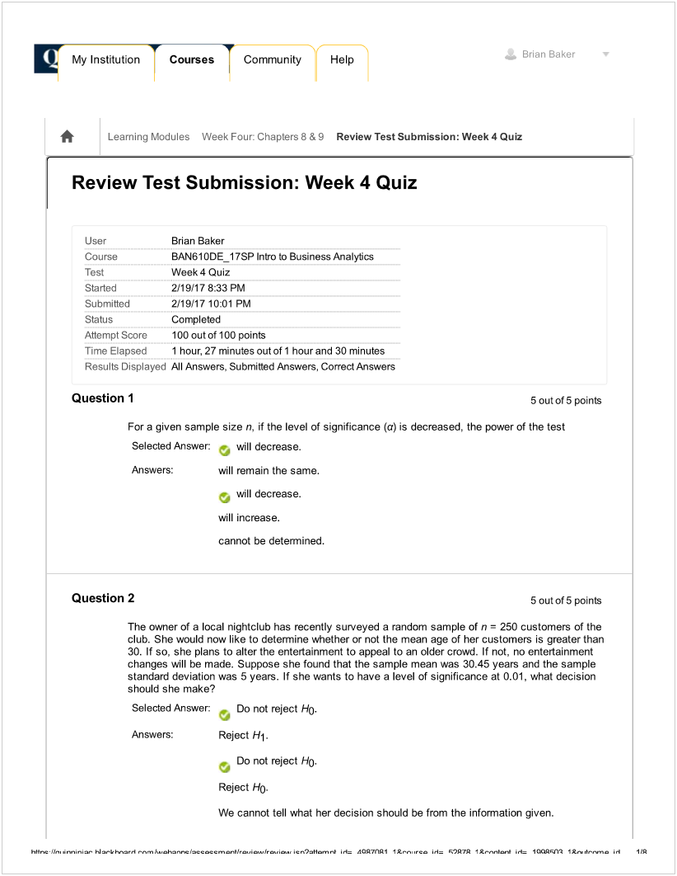

![Machine generated alternative text:
Question 3 5outof5 points
Which of the following statements is n tn.ie about the level of significance in a hypothesis test?
Selected The significance level is another name for Type Il error.
Answer:
Answers: The larger the level of significance, the more likely you are to reject the null
hypothesis.
The level of significance is the maximum risk we are willing to accept in making a
Type I error.
The significance level is another name for Type Il error.
The significance level is also called the a level.
Question 4 5outof5points
The marketing manager for an automobile manufacturer is interested ¡n determining the proportion of
new compact-car owners who would have purchased a knee airbag if it had been available for an
additional cost of $300. The manager believes from previous information that the proportion ‘s 0.30.
Suppose that a survey of 200 new compact-car owners is selected and 79 indicate that they would
have purchased the knee airbag. If you were to conduct a test to determine whether there is
evidence that the proportion is different from 0.30 and decided not to reject the null hypothesis.
what conclusion could you reach?
Selected Answer: There is not sufficient evidence that the proportion is not 0.30.
Answers: There is not sufficient evidence that the proportion is not 0.30.
There is not sufficient evidence that the proportion is 0.30.
There is sufficient evidence that the proportion is 0.30.
There is sufficient evidence that the proportion is not 0.30.
Question 5 5outof5points
The quality control engineer for a furniture manufacturer is interested in the mean amount of force
necessary to produce cracks in stressed oak furniture. She performs a two-tail test of the null
hypothesis that the mean for the stressed oak furniture is 650. The calculated value of the Z test
statistic Is a positive number that leads to a p-value of 0.080 for the test.
Suppose the engineer had decided that the alternative hypothesis to test was that the mean was
less than 650. What would be the p-value of this one-tail test?
Selected Answer 0.960
Answers: 0.840
0.960
0.160
0.040
h+$rc Ik.  hi h.nl  .h2nrc cccml  cn),Kn, nl i, AOR7fl1  rc l 97fi I *,nlDnl i4 I OOÇfl 1*n. ,lnnn, .,l )?](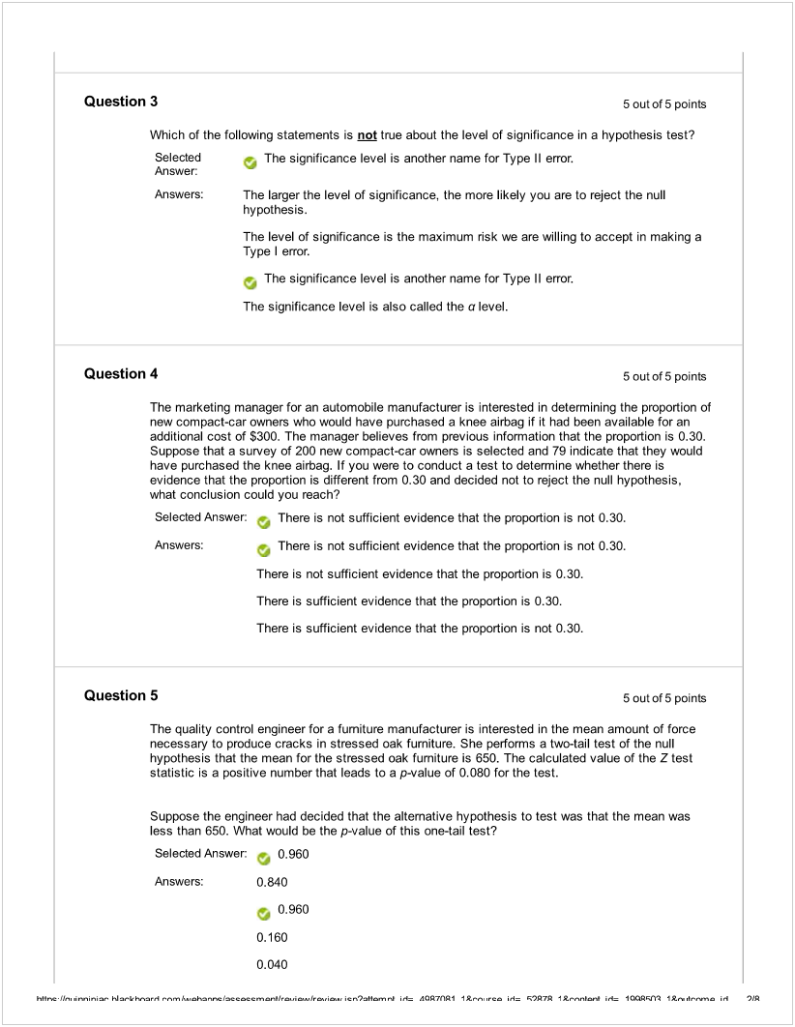)

![Machine generated alternative text:
Question 6 5outof5 points
A student claims that he can correctly identify whether a person is a business major or an
agriculture major by the way the person dresses. Suppose in actuality that if someone is a business
major. he can correctly identify that person as a business major 87% of the time. When a person is
an agriculture major, the student will incorrectly identify that person as a business major 16% of the
time. Presented with one person and asked to identify the major of this person (who is either a
business or an agriculture major), he considers this to be a hypothesis test with the null hypothesis
being that the person is a business major and the alternative that the person is an agriculture major.
What would be a Type Il erro??
Selected
Answer: Saying that the person is a business major when in fact the person is an
agriculture major.
Answers: Saying that the person is an agriculture major when in fact the person is an
agriculture major.
Saying that the person is an agnculture major when in fact the person is a
business major.
Saying that the person is a business major when in fact the person is an
agriculture major.
Saying that the person is a business major when in fact the person is a business
major.
Question 7 5outof5 points
The symbol for the confidence coefficient of a statistical test is
Selected Answer: - 1 - a.
Answers: a.
1-a.
p.
1 -ß.
Question 8 5outof5points
A student claims that he can correctly identify whether a person is a business major or an
agriculture major by the way the person dresses. Suppose in actuality that If someone is a business
major, he can correctly identify that person as a business major 87% of the time. When a person is
an agriculture major, the student will incorrectly identify that person as a business major 16% of the
time. Presented with one person and asked to identify the major of this person (who is either a
business or an agriculture major), he considers this to be a hypothesis test with the null hypothesis
being that the person is a business major and the alternative that the person is an agriculture major.
What would be a Type I erro??
h+$r,c 1k., .rini  hi .-k h.nl     v.b i, AOR7fl1 t.. ,rc l )7 I *nnœ.b i4 I QQÇfl 1*,,. ,bv.v.n, .,l 21P](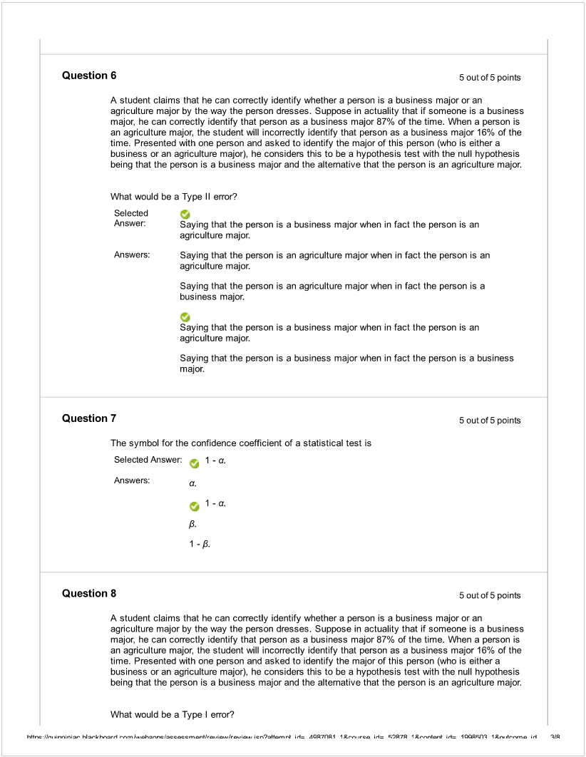)

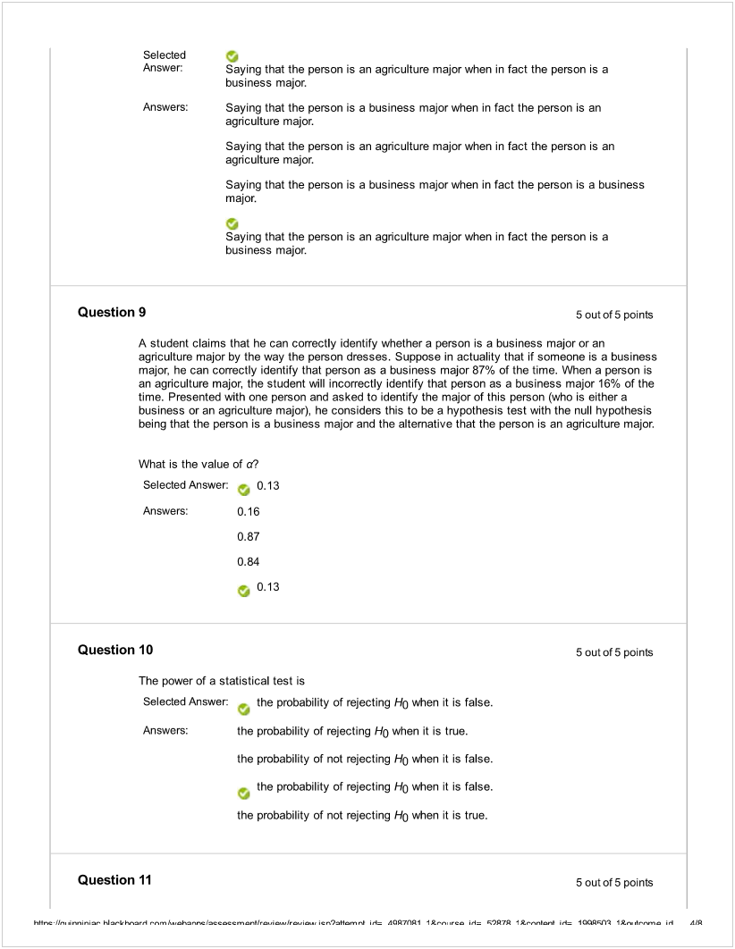

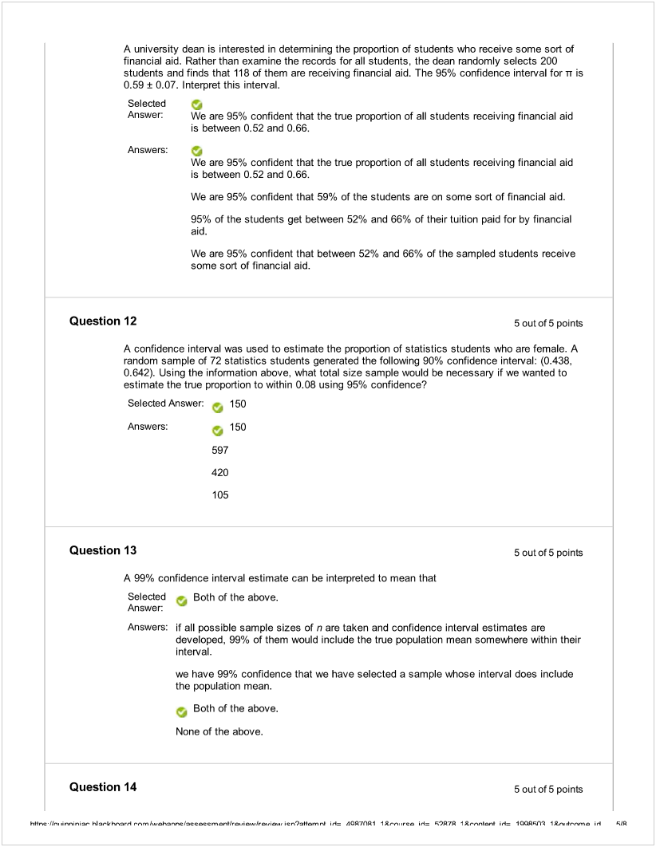

![Machine generated alternative text:
As an aid to the establishment of personnel requirements, the director of a hospital wishes to
estimate the mean number of people who are admitted to the emergency room during a 24-hour
period. The director randomly selects 64 different 24-hour periods and determines the number of
admissions for each. For this sample, X = 396 and S = 100. Which of the following assumptions is
necessary in order for a confidence interval to be valid?
Selected Answer:  None of these assumptions are necessary.
Answers: The population sampled from has an approximate normal distribution.
The mean of the sample equals the mean of the population.
The population sampled from has an approximate t distribution.
- None of these assumptions are necessary
QuestIon 15 5outof5points
A major department store chain is interested in estimating the mean amount its credit card
customers spent on their first visit to the chain’s new stcwe in the mall. Fifteen credit card accounts
were randomly sampled and analyzed with the following results: X = $50.50 and S = 20. Assuming
the distribution of the amount spent on their first visit is normal, what is the shape of the sampling
distribution of the sample mean that will be used to create the desired confidence interval for p?
Selected Answer a t distribution with 14 degrees of freedom
Answers: approximately normal with a mean of $50.50
a standard normal distflbution
a t distribution with 15 degrees of freedom
a f distribution with 14 degrees of freedom
Question 16 5outof5points
A poll was conducted by the marketing department of a video game company to determine the
popularity of a new game that was targeted to be launched in three months. Telephone interviews
with 1.500 young adults were conducted which revealed that 49% said they would purchase the new
game. The margin of error s ±3 percentage points.
1,500 is the size of the
Selected Answer ç sample.
Answers: proportion.
population.
frame.
sample.
Question 17 5outof5points
The head librarian at the Library of Congress has asked her assistant for an interval estimate of the
1k,,  hi .-k kw,,n m hnr,c íccocc,  cn),Kn, nl i, AOR7fl1 t t,n rc l 97fi I *nnlœ,l i.4 I  1*,.  .l 1R](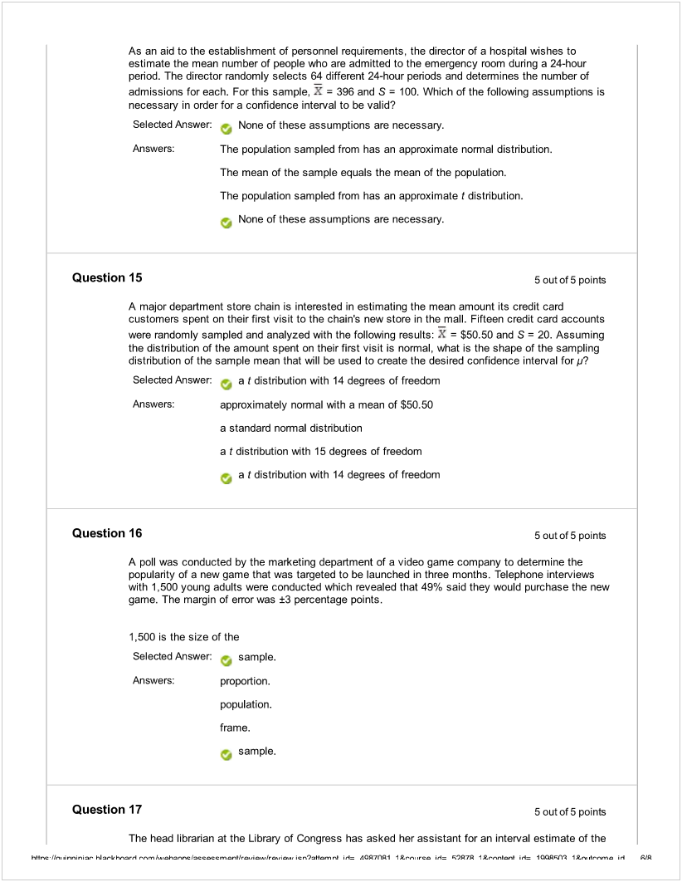)

![Machine generated alternative text:
mean number of books checked out each day. The assistant provides the following interval
estimate: from 740 to 920 books per day. If the head librarian knows that the population standard
deviation is 150 books checked out per day, and she asked her assistant to use 25 days of data to
construct the interval estimate, what confidence level can she attach to the interval estimate?
Selected Answer: -, 99.7%
Answers: 95.4%
99.0%
98.0%
99.7%
QuestIon 18 5outof5points
It Is desired to estimate the mean total compensation of CEOs In the Service Industry. Data were
randomly collected from 18 CEOs and the 95% confidence interval was calculated to be
($2.181.260. $5.836,180). Which of the following interpretations is correct?
Selected ,
Answer: We are 95% confident that the mean total compensation of all CEOs in the Service
industry falls in the interval $2,181,260 to $5,836,180.
Answers: ,
We are 95% confident that the mean total compensation of all CEOs in the Service
industry falls in the interval $2,181,260 to $5,836,180.
95% of the sampled total compensation values fell between $2.181.260 and
$5.836,180.
We are 95% confident that the mean of the sampled ŒOs falls in the interval
$2.181.260 to $5,836,180.
In the population of Service industry CEOs, 95% of them will have total
compensations that fall in the interval $2,181,260 to $5,836.180.
Question 19 5outof5points
Suppose a 95% confidence interval for p turns out to be (1,000, 2,100). To make more useful
inferences from the data, it is desired to reduce the width of the confidence interval. Which of the
following will result in a reduced interval width?
Selected Answer -, Increase the sample size.
Answers:  Increase the sample size.
Increase the population mean.
Increase the sample mean.
Increase the confidence level.
Question 20 5outof5points
A major department store chain is interested in estimating the mean amount its credit card
h+$r,c 1k,,  hi .-k hw,n m 1..h2nr,c ccôccml  c,’),Kn, nl i, AOR7fl1 t t,n ,rc l 97fi I *,“,,nlœ,I i.4 I  IL”,. ,I.,.,, .,l 7?P](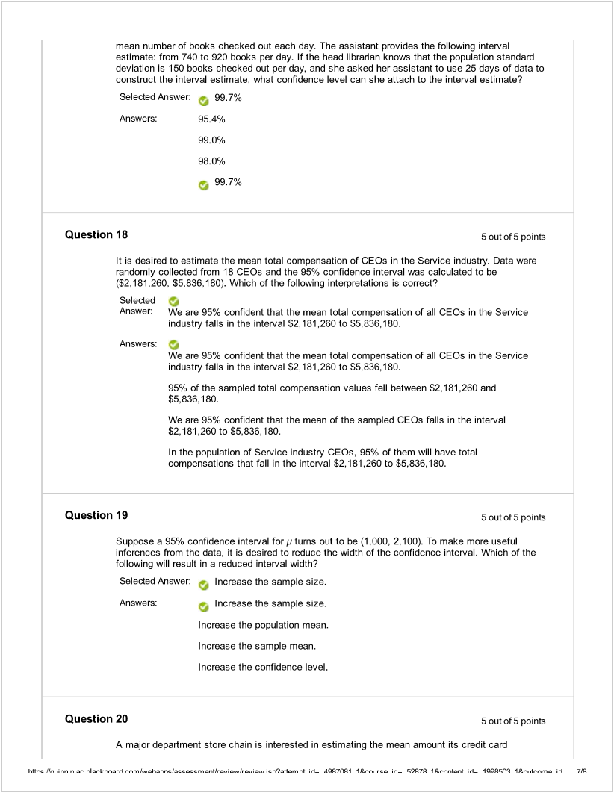)

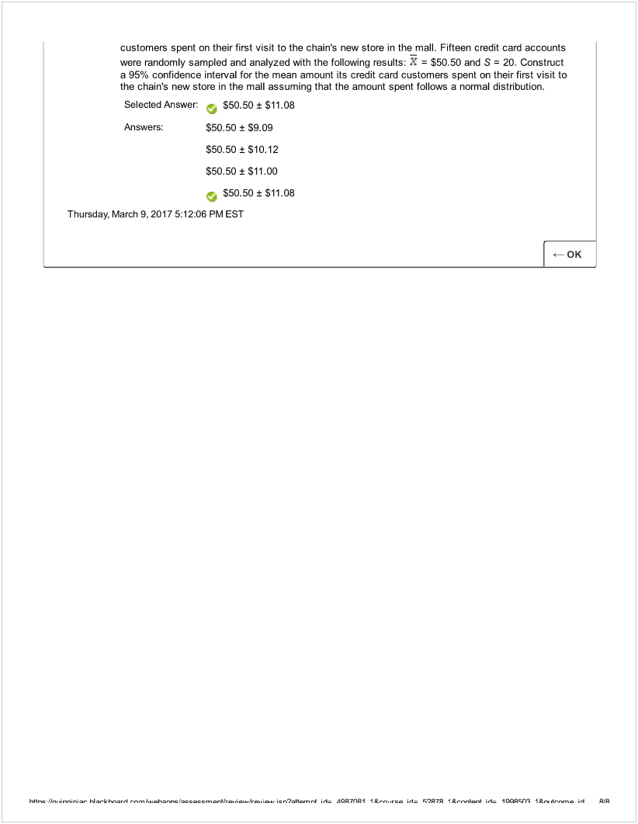

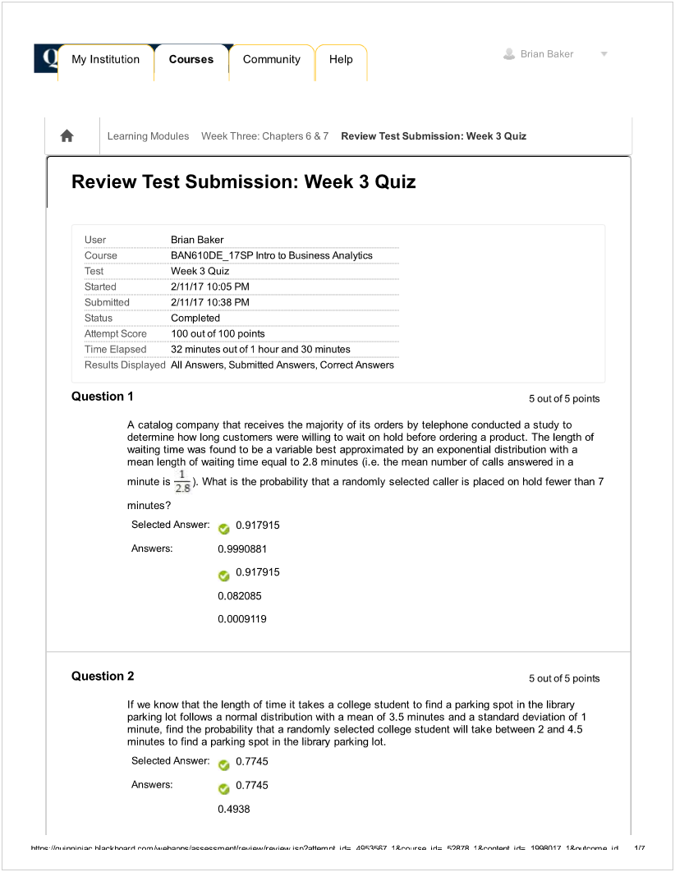

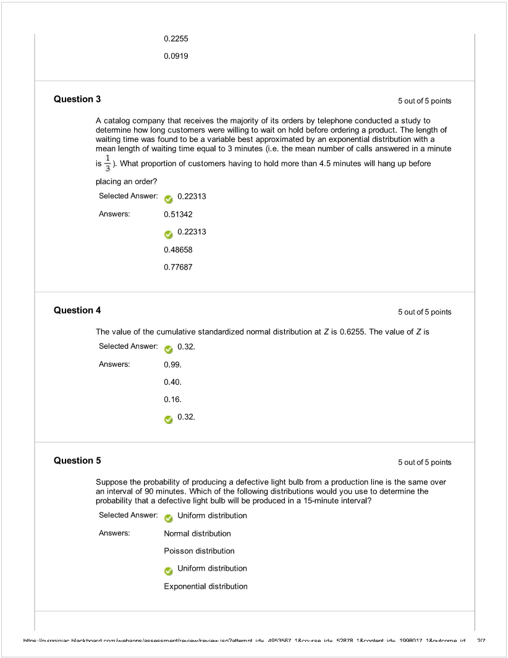

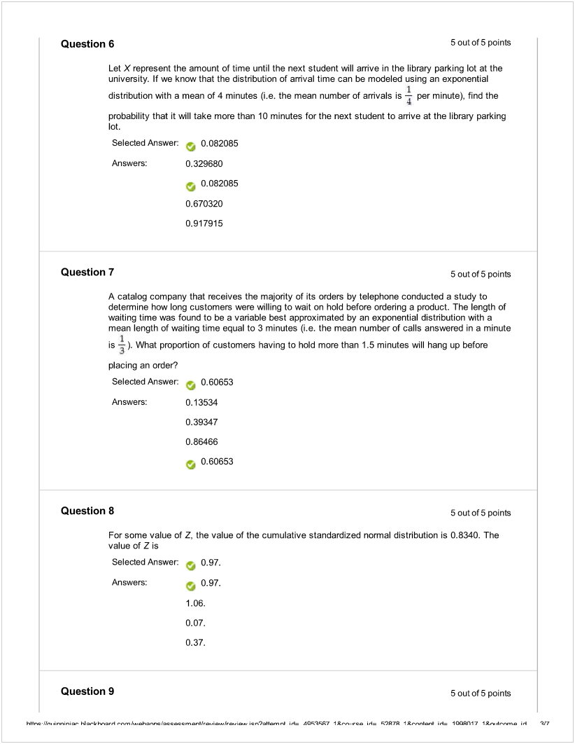

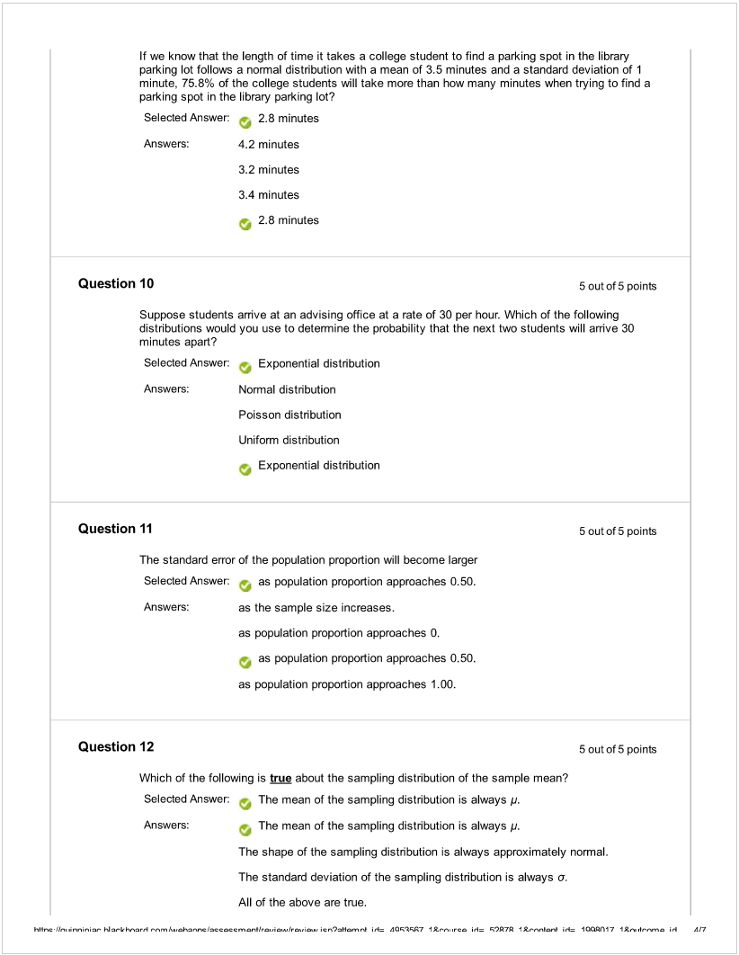

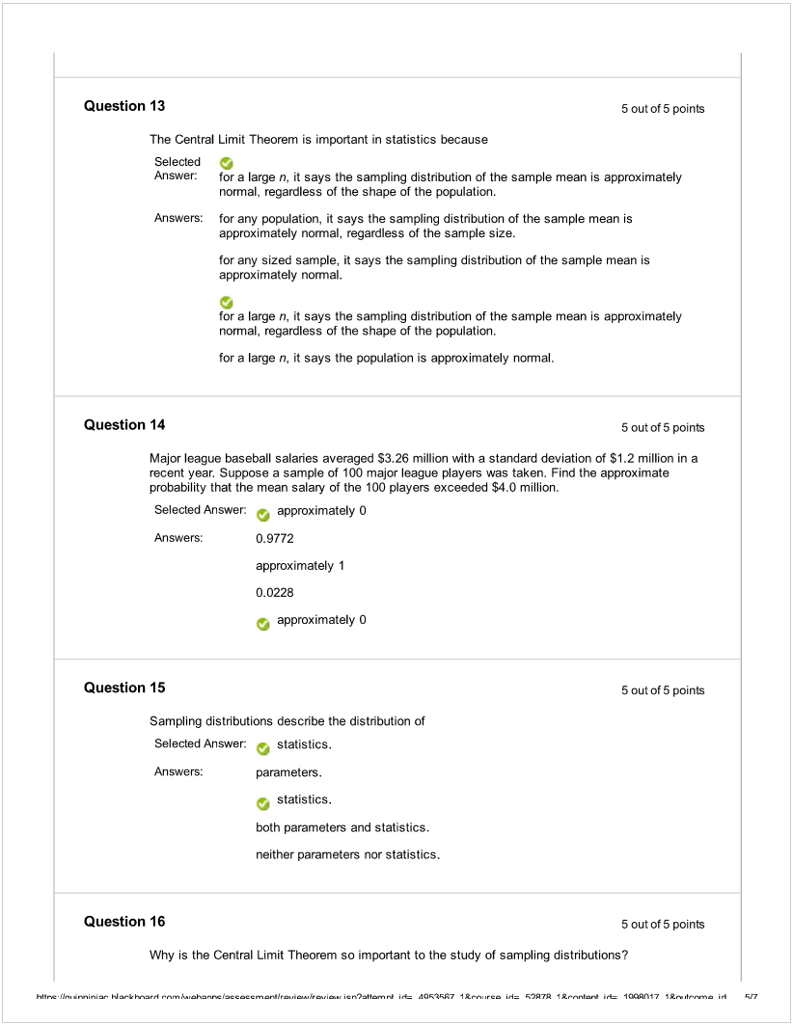

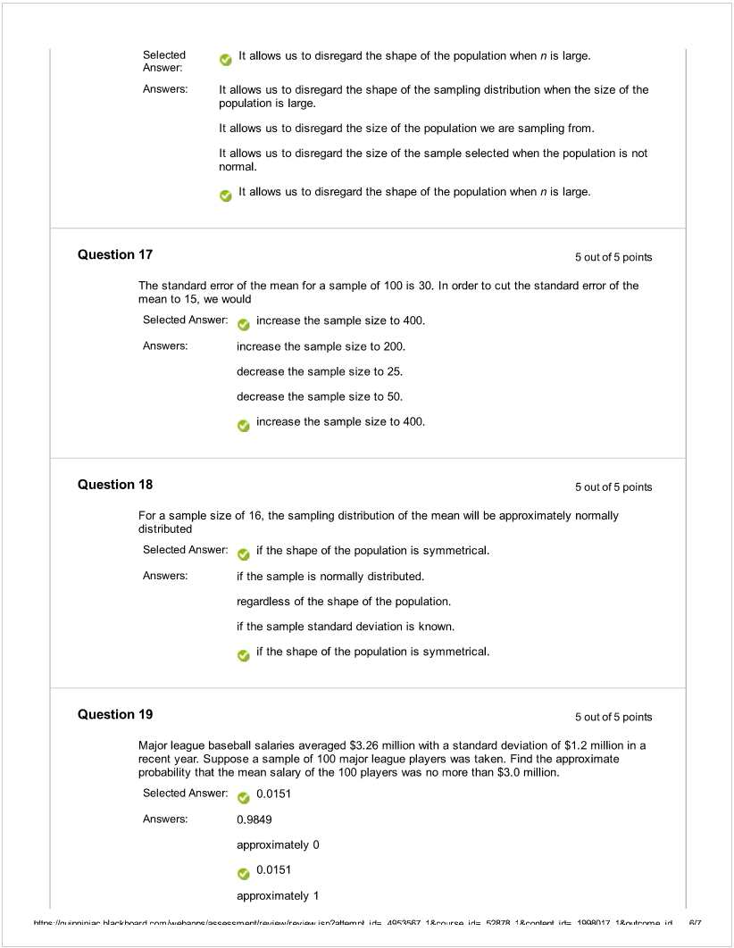

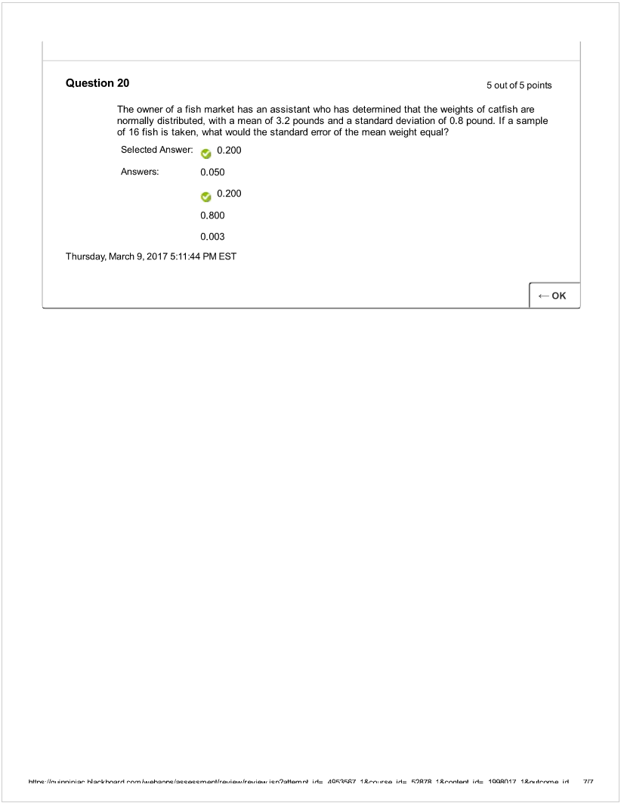

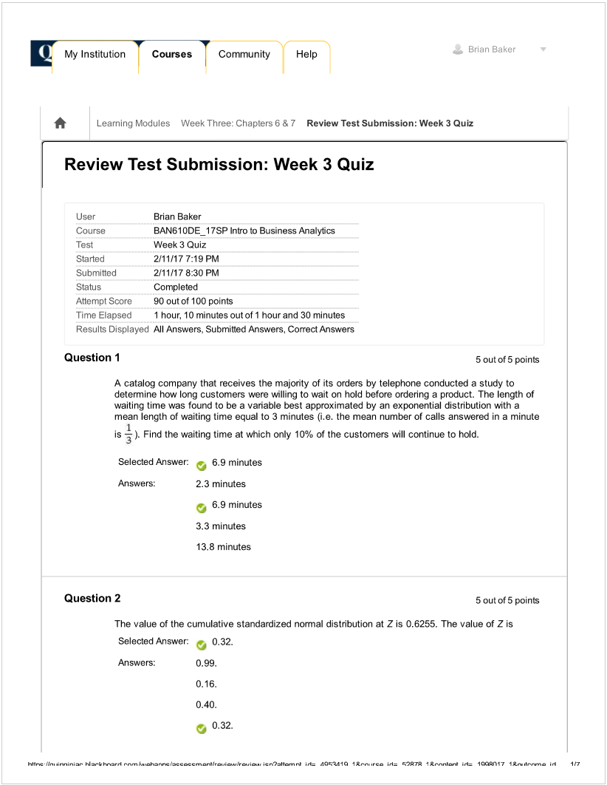

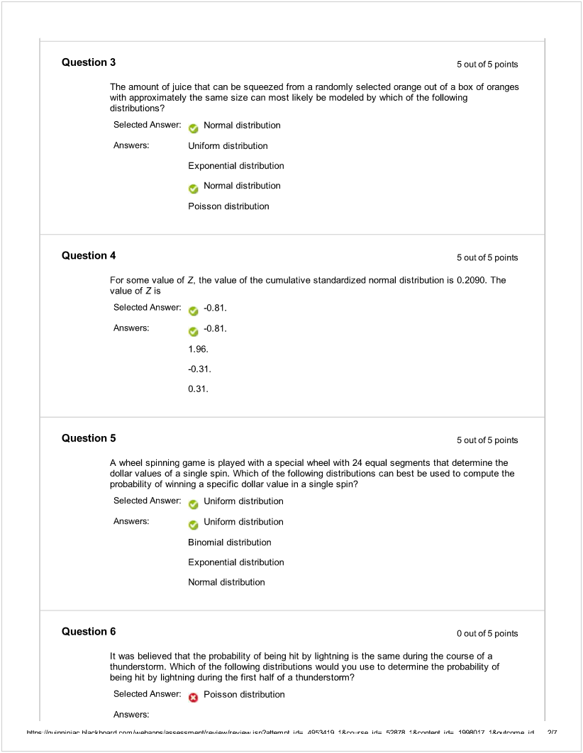

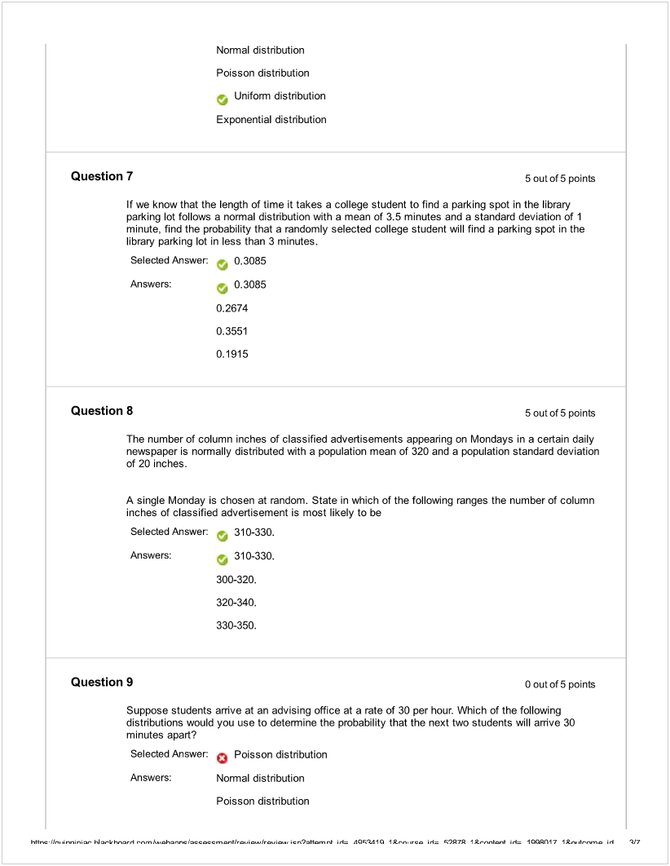

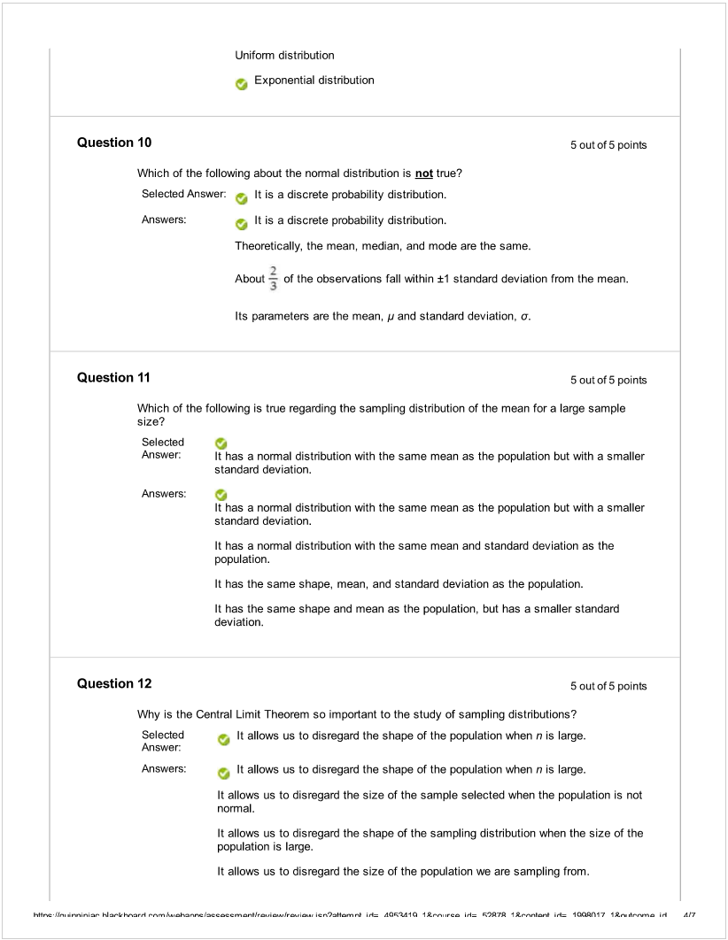

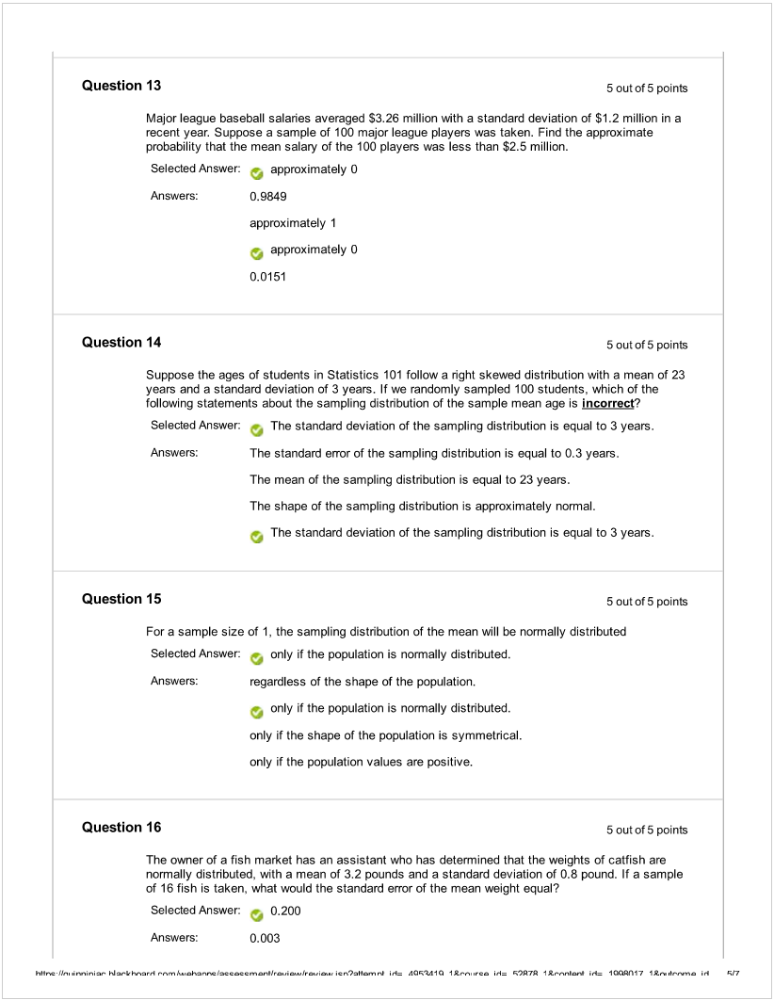

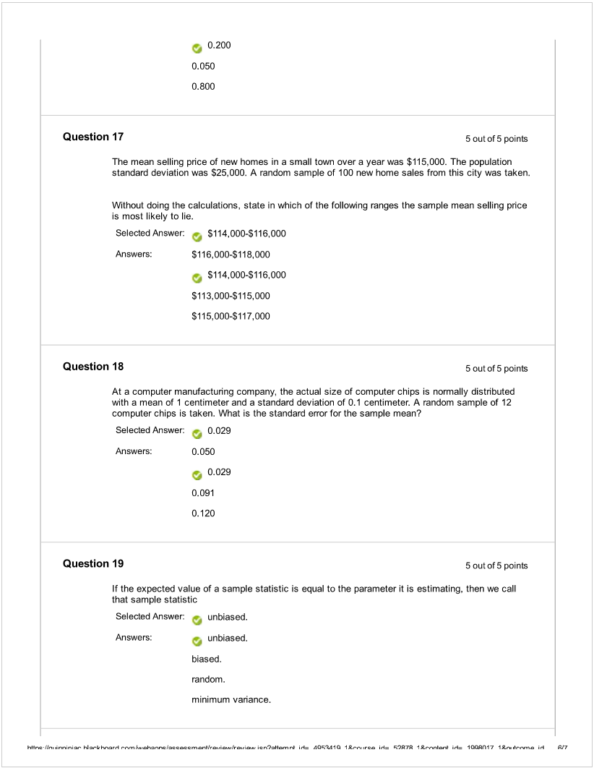

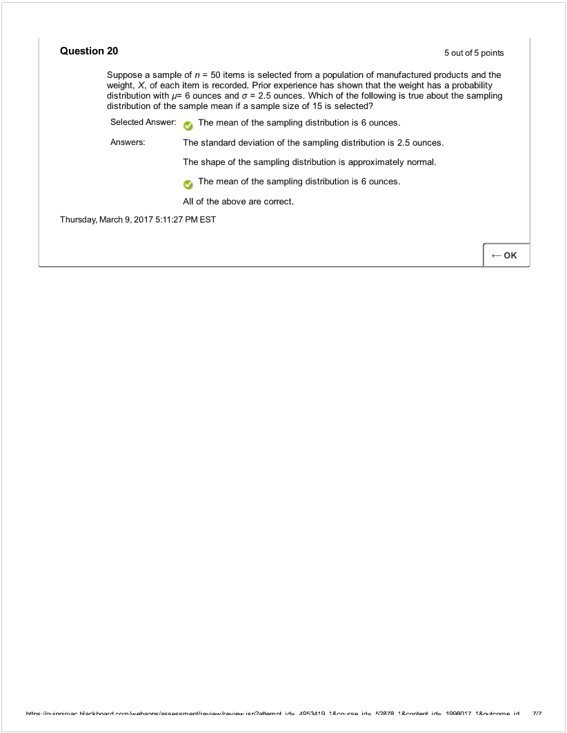

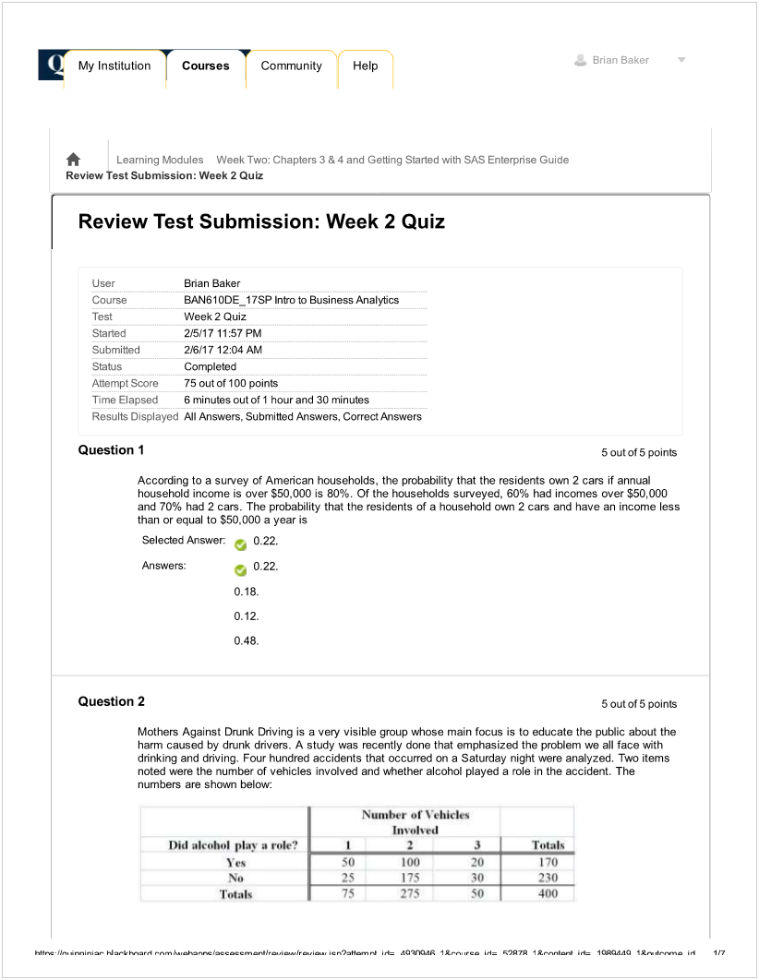

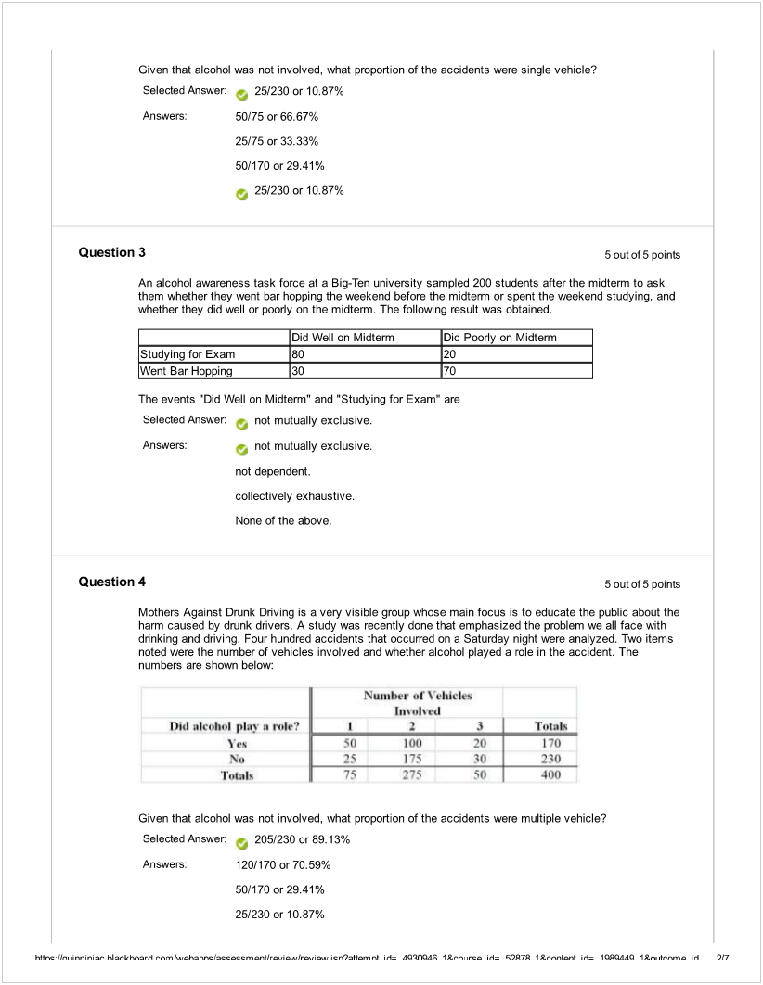

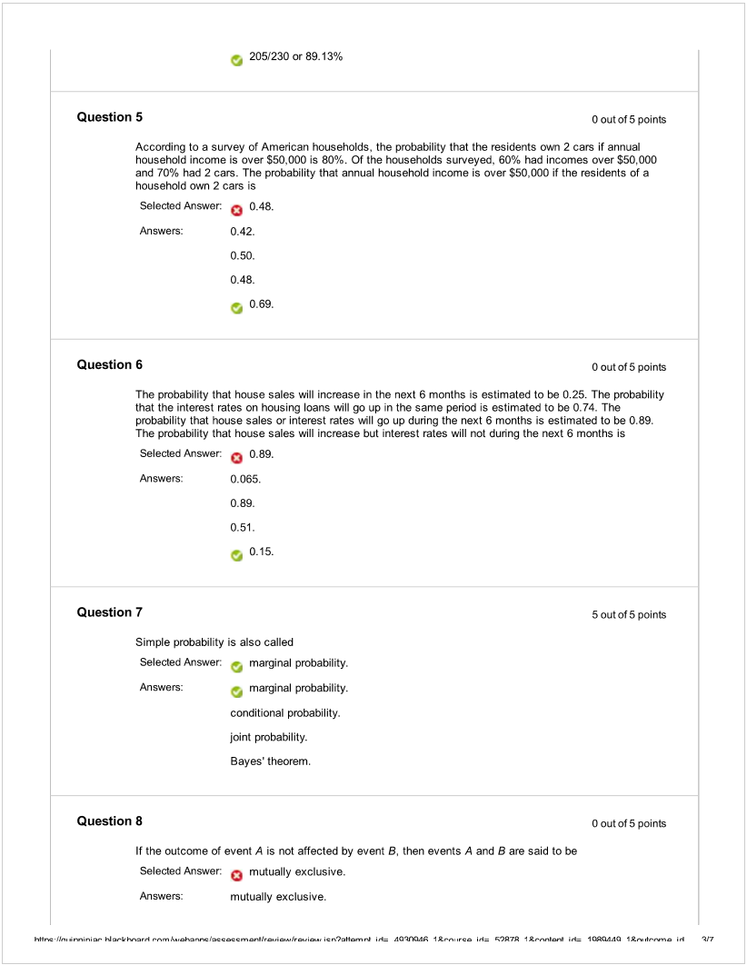

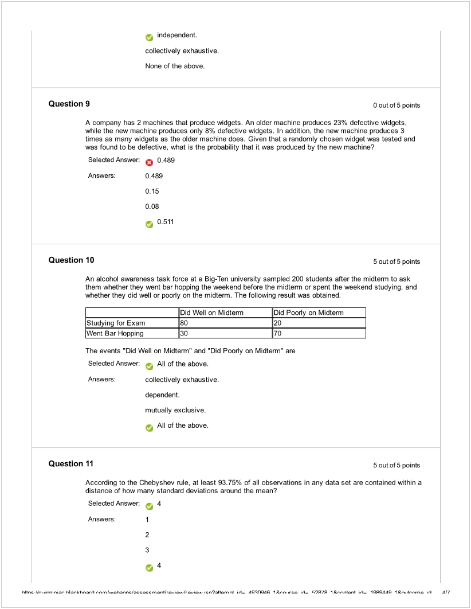

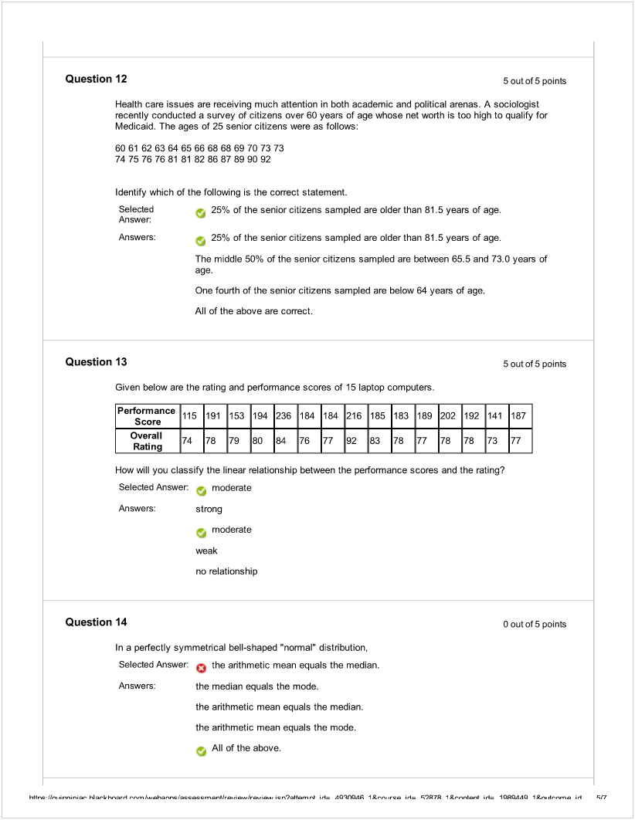

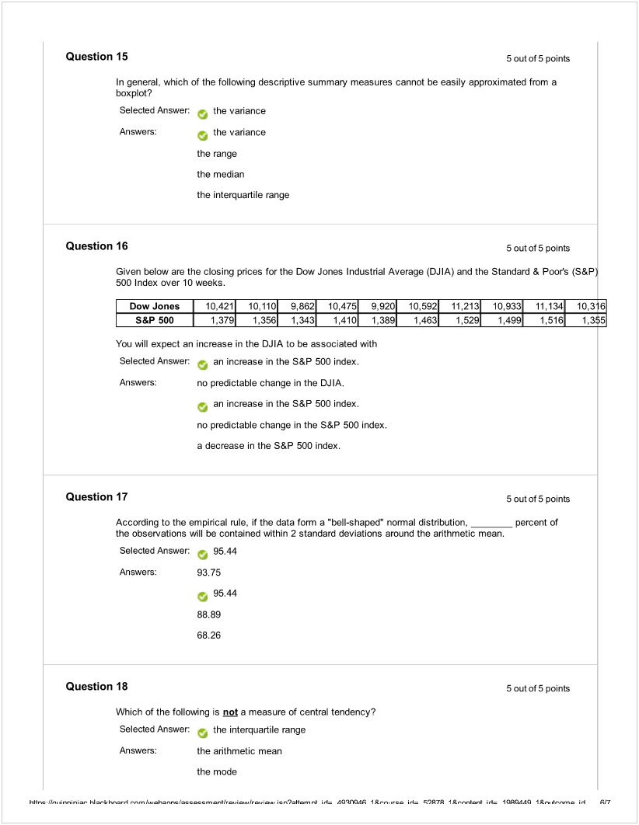

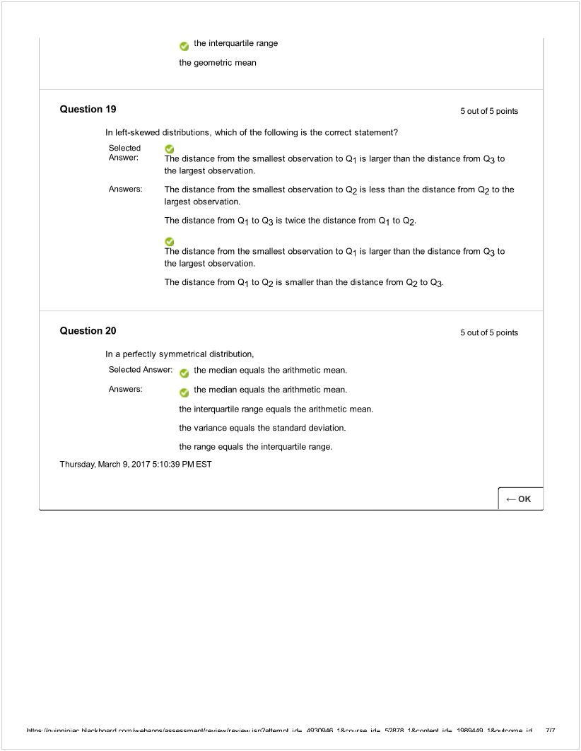

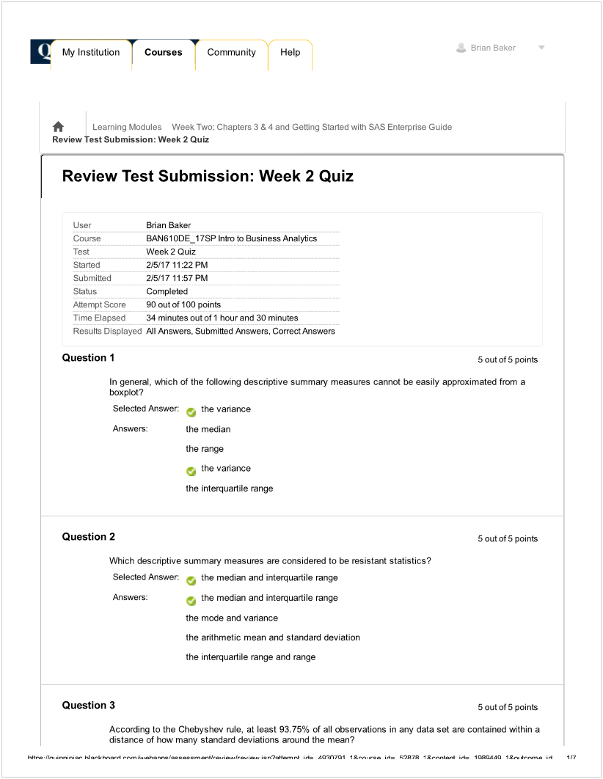

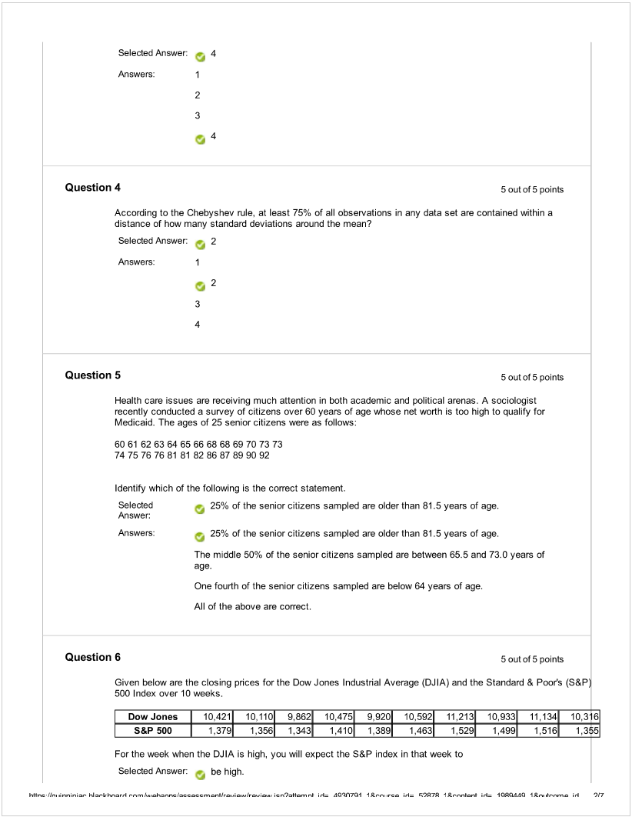

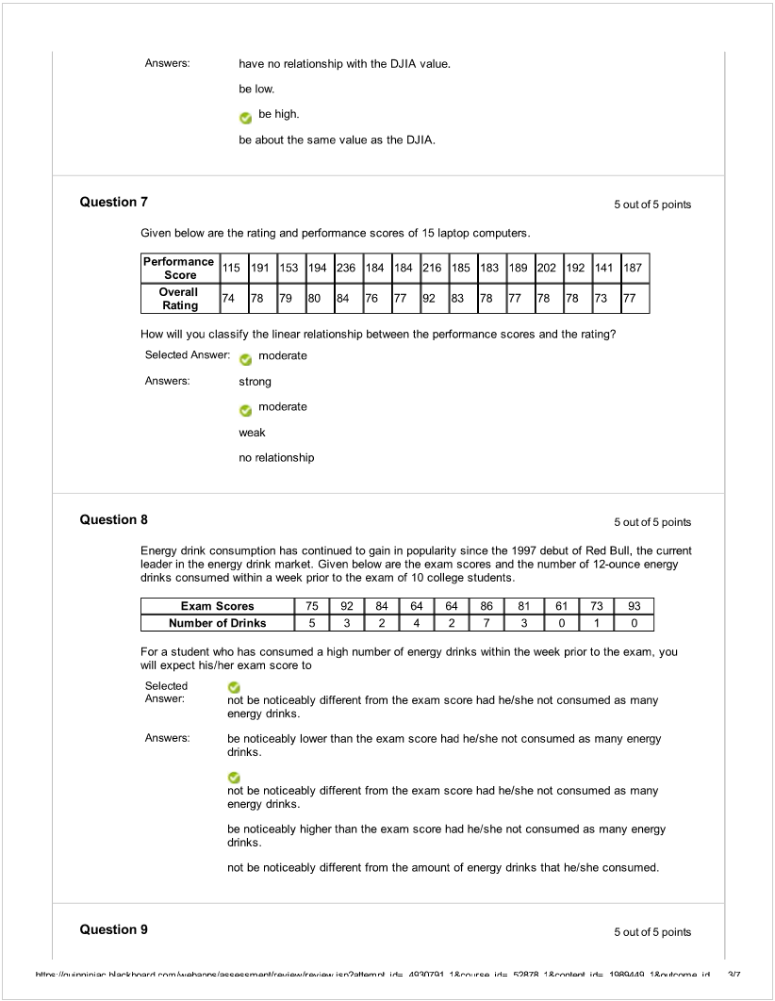

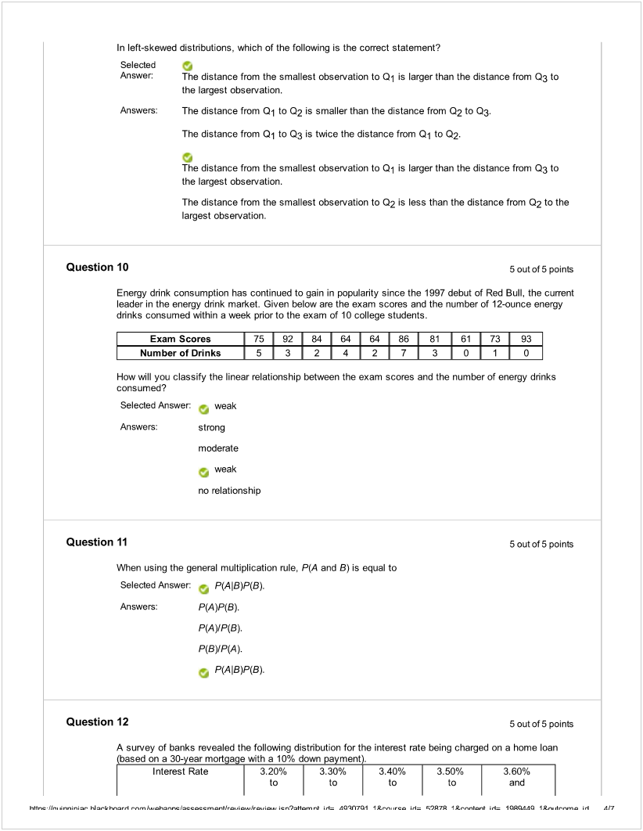

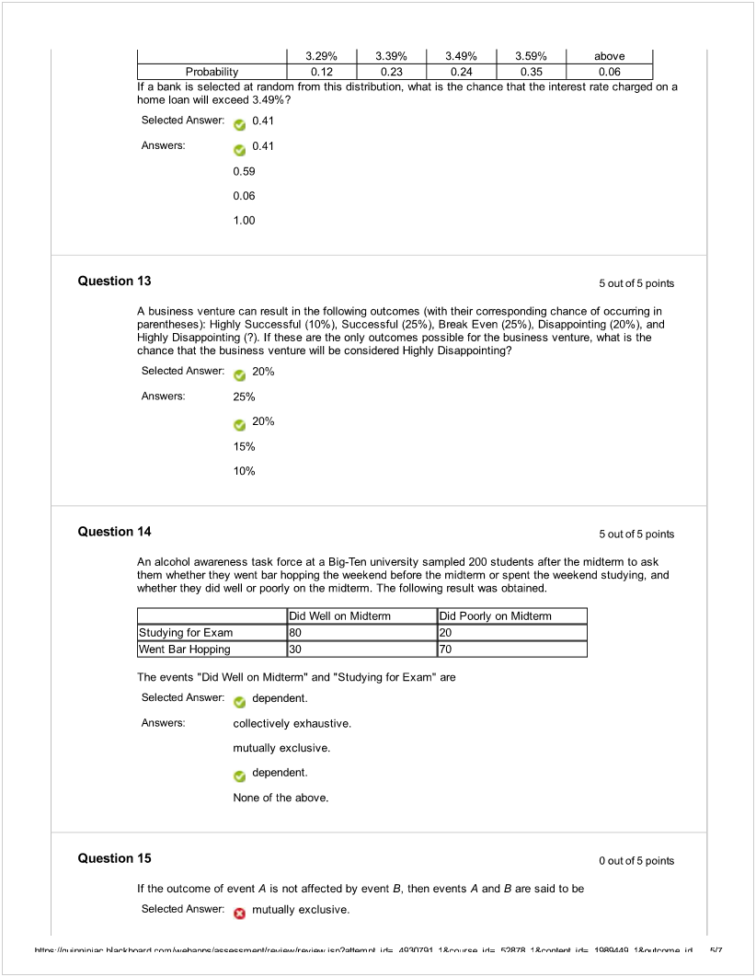

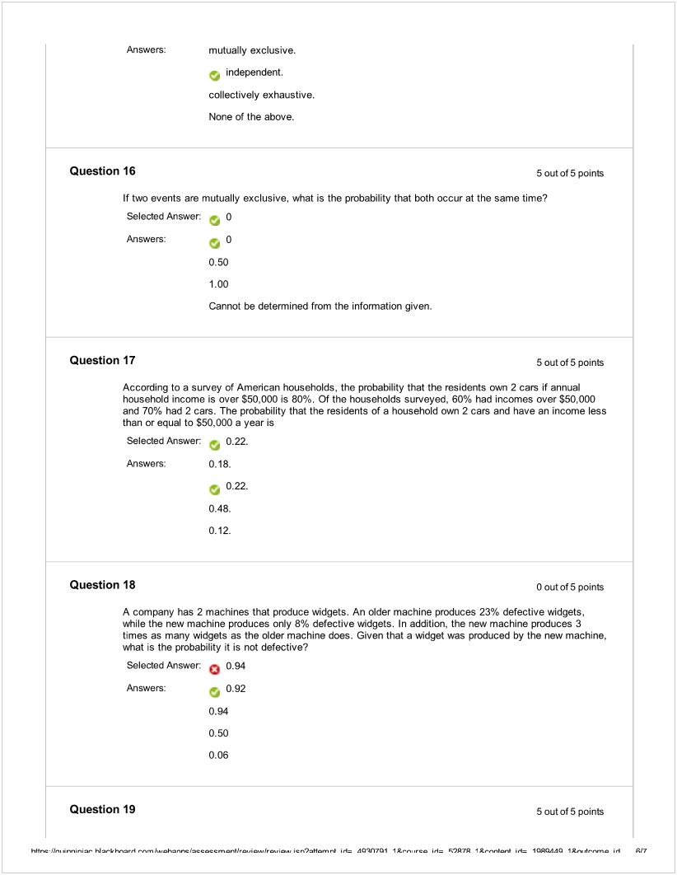

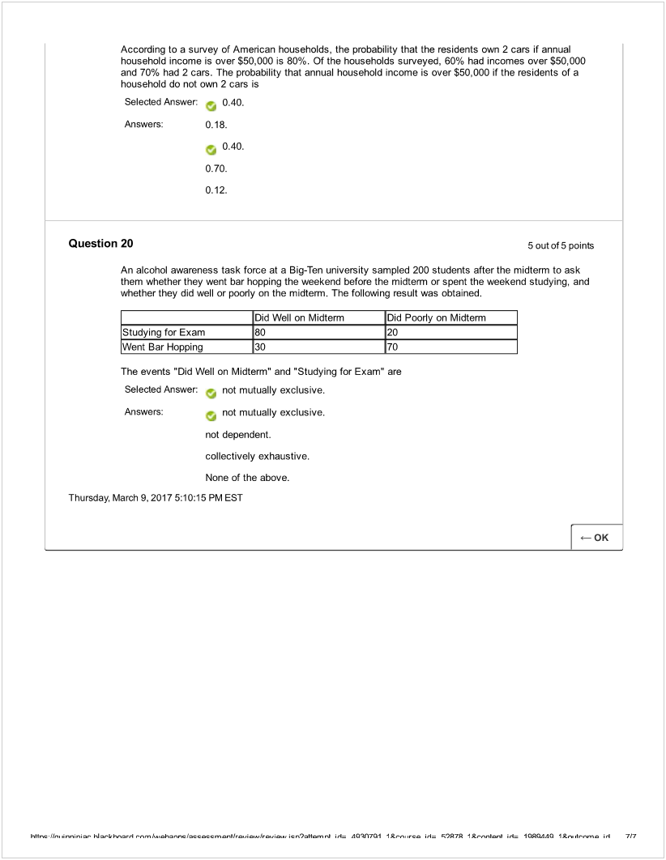

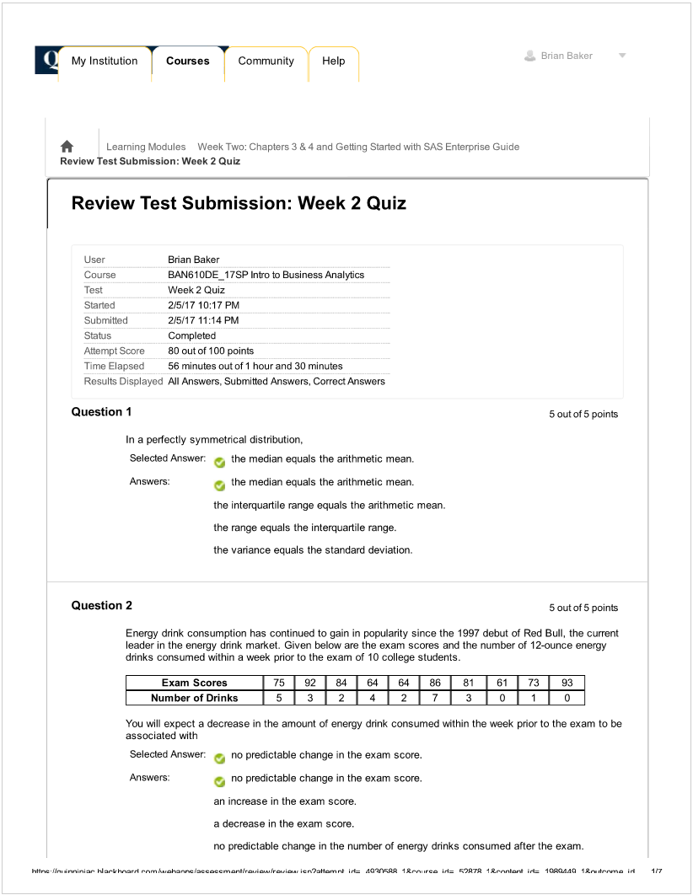

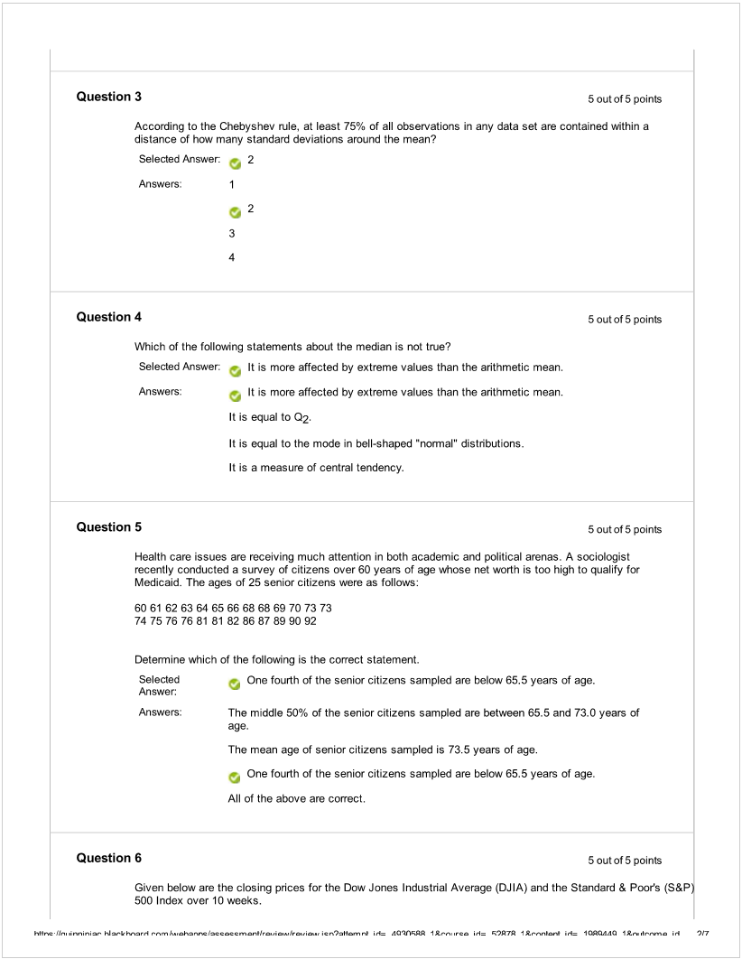

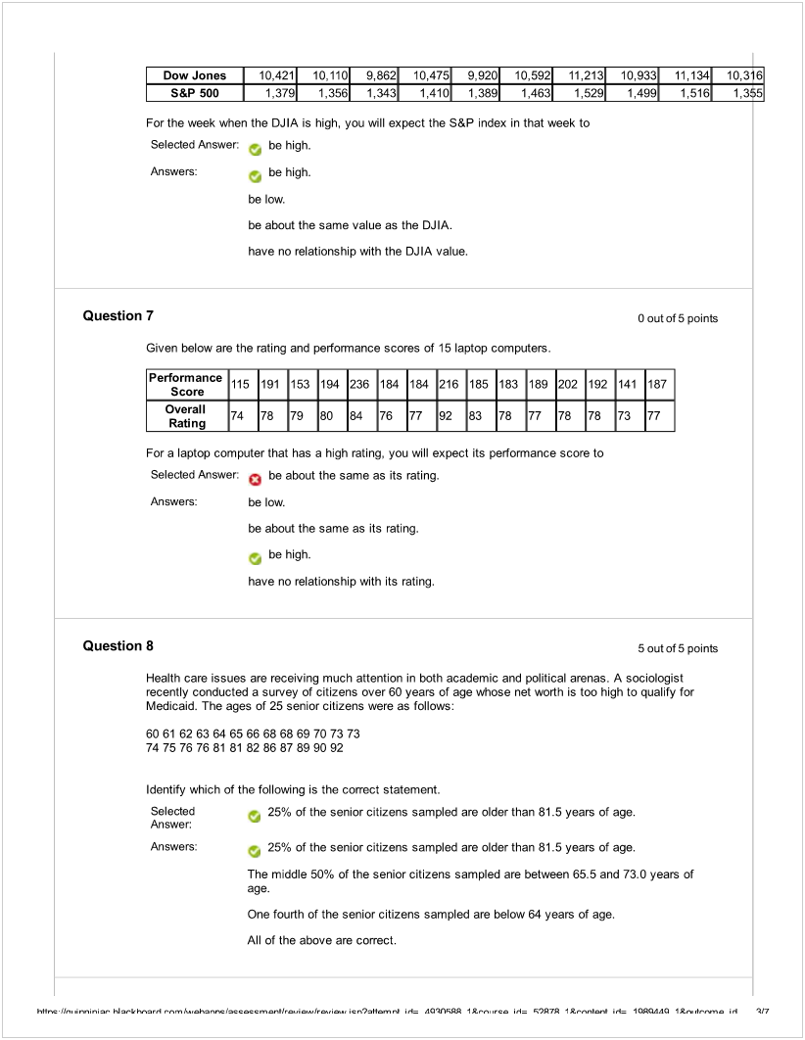

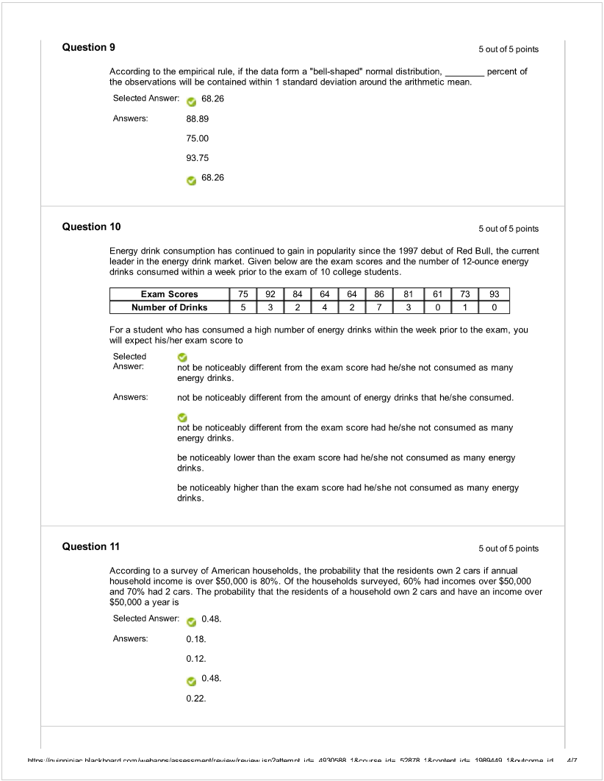

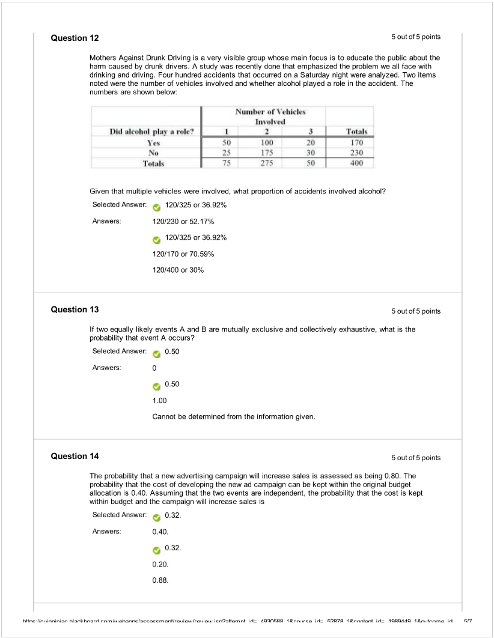

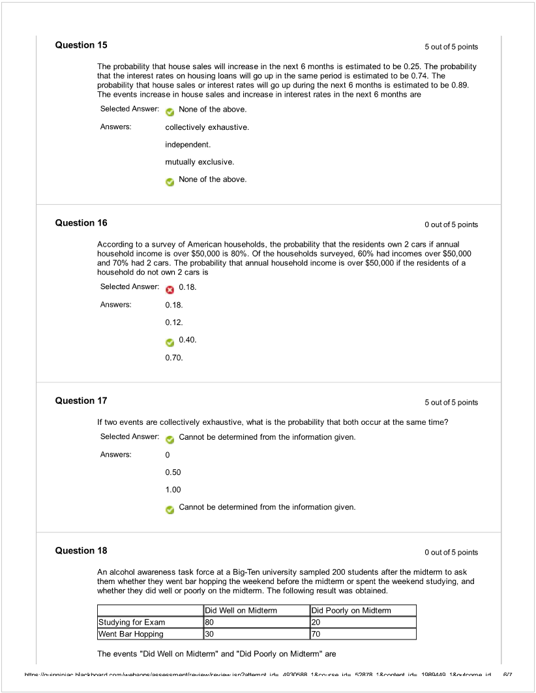

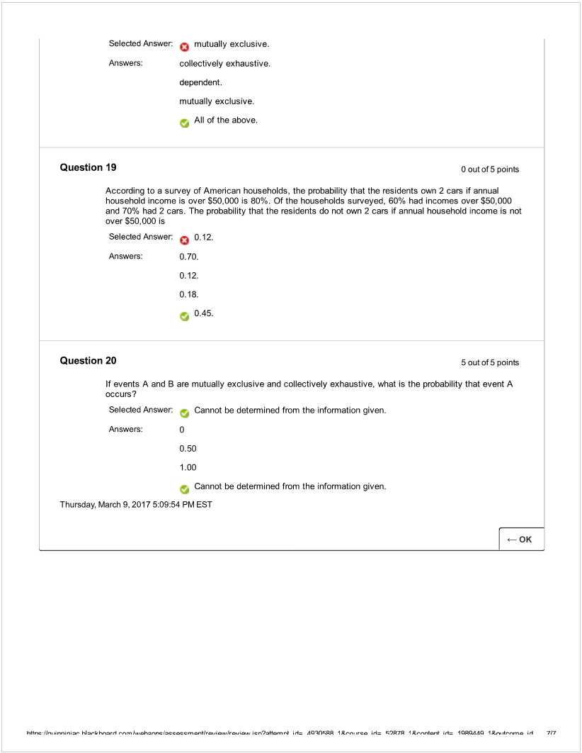

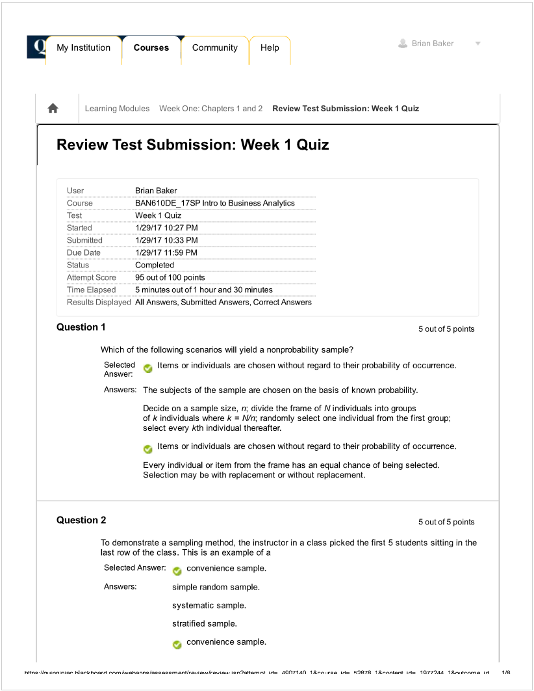

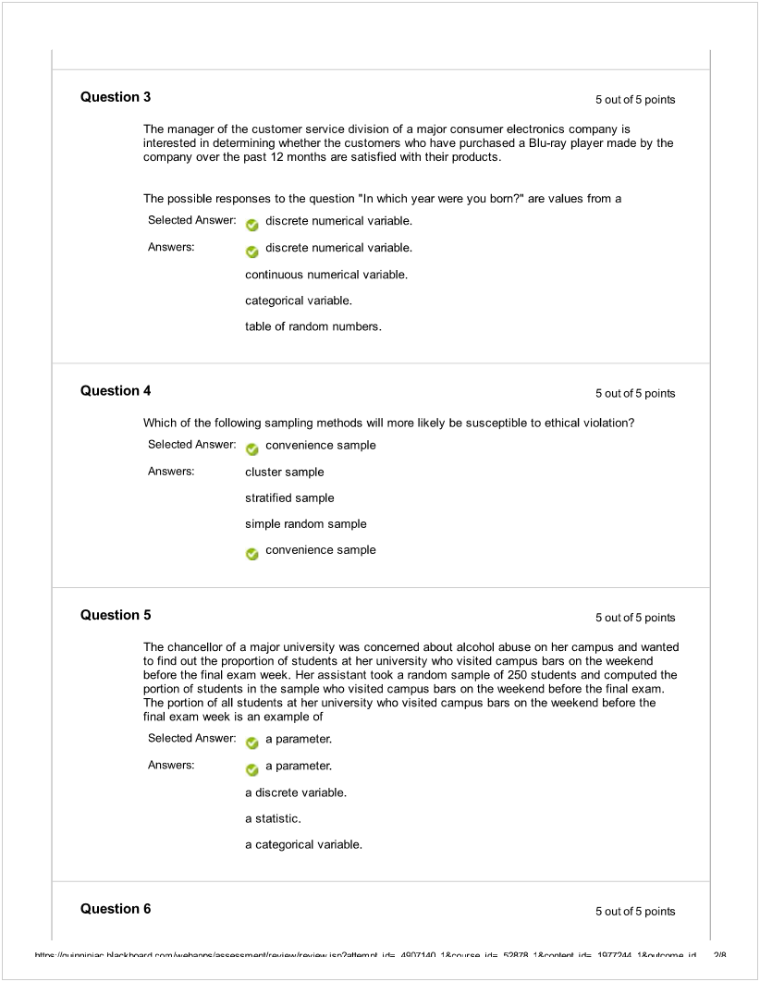

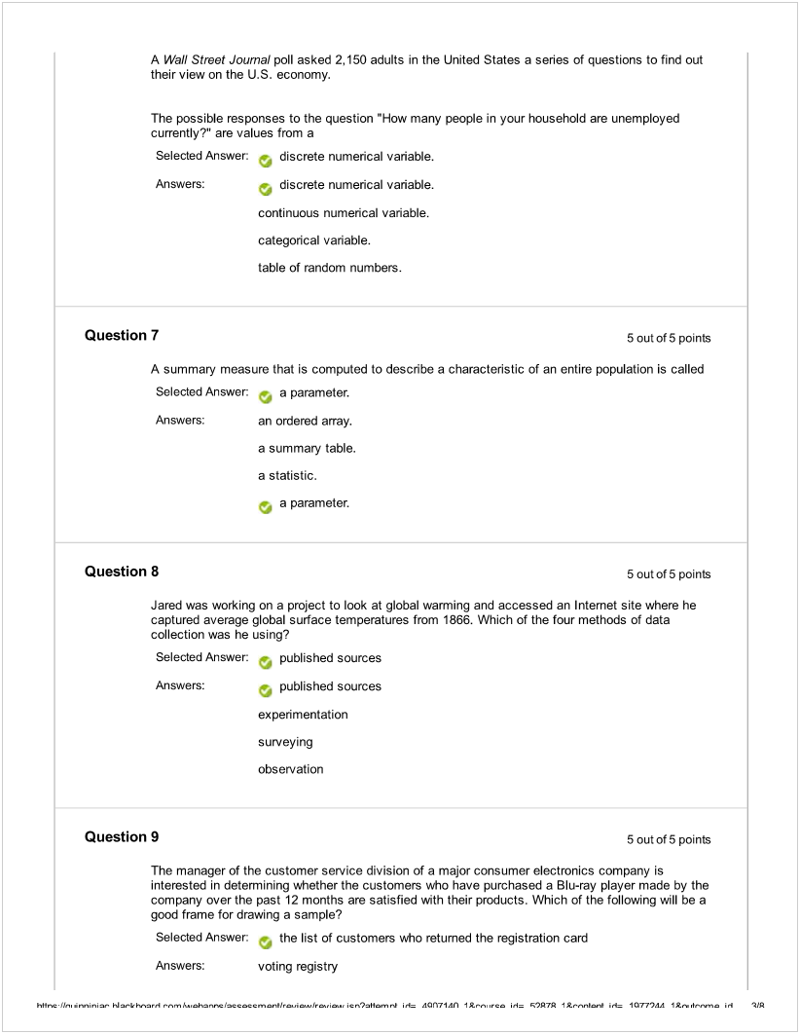

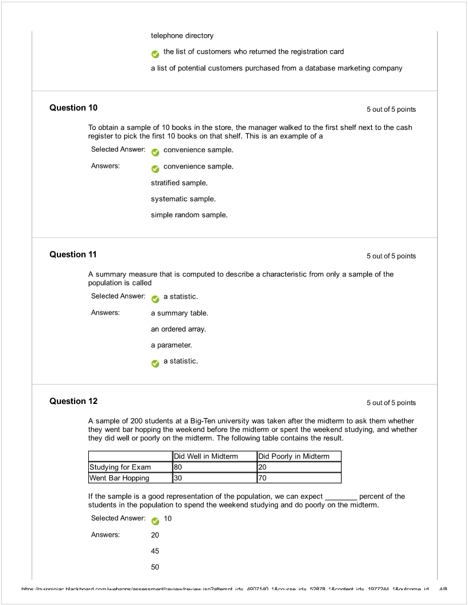

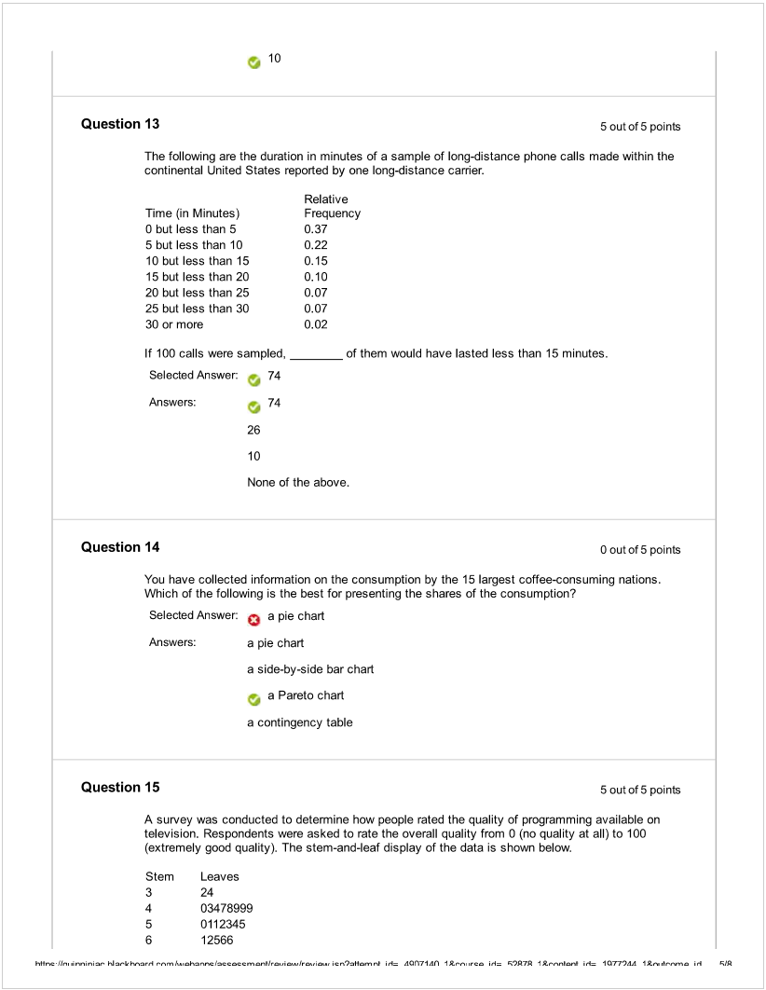

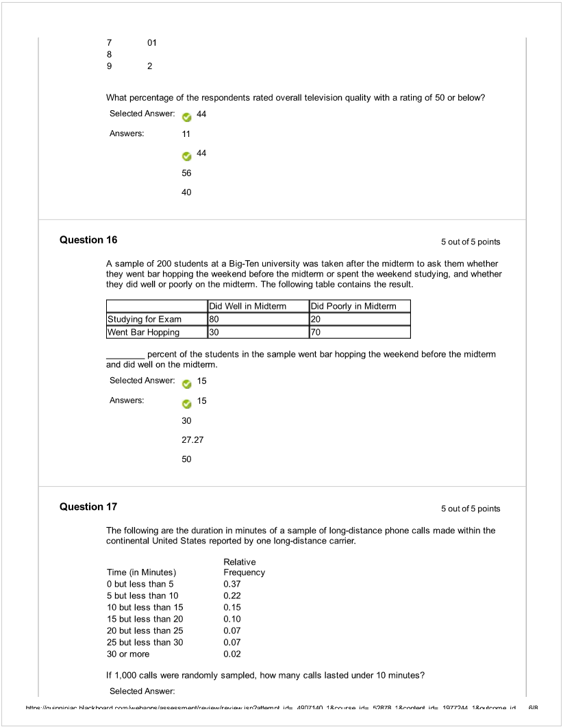

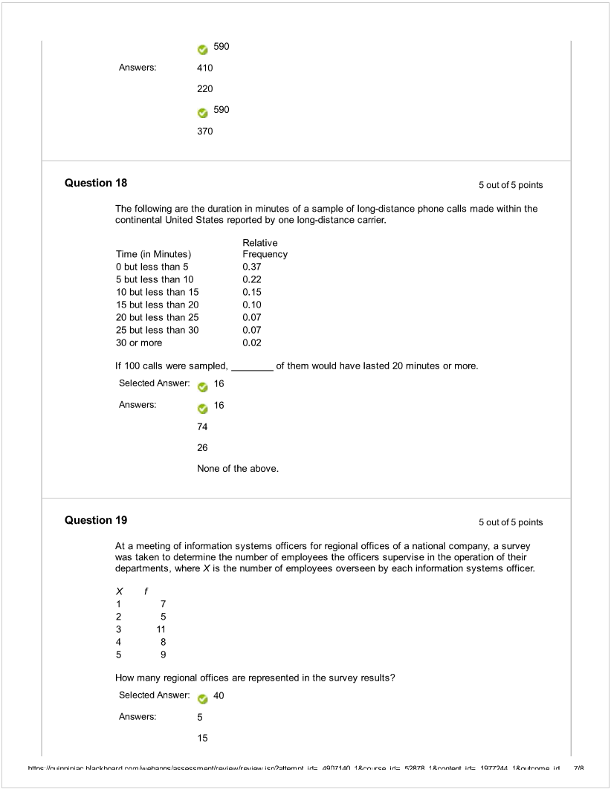

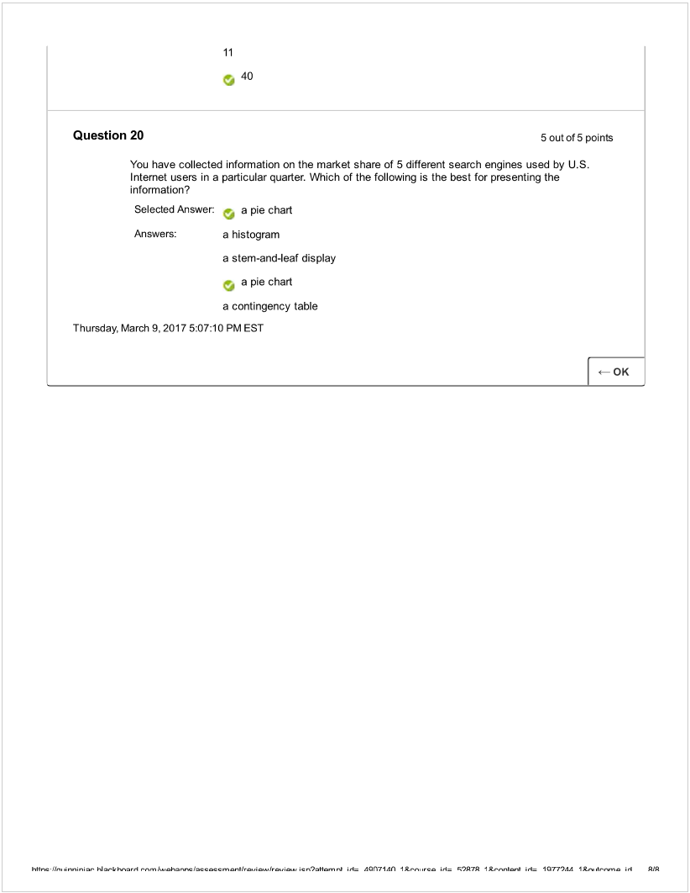

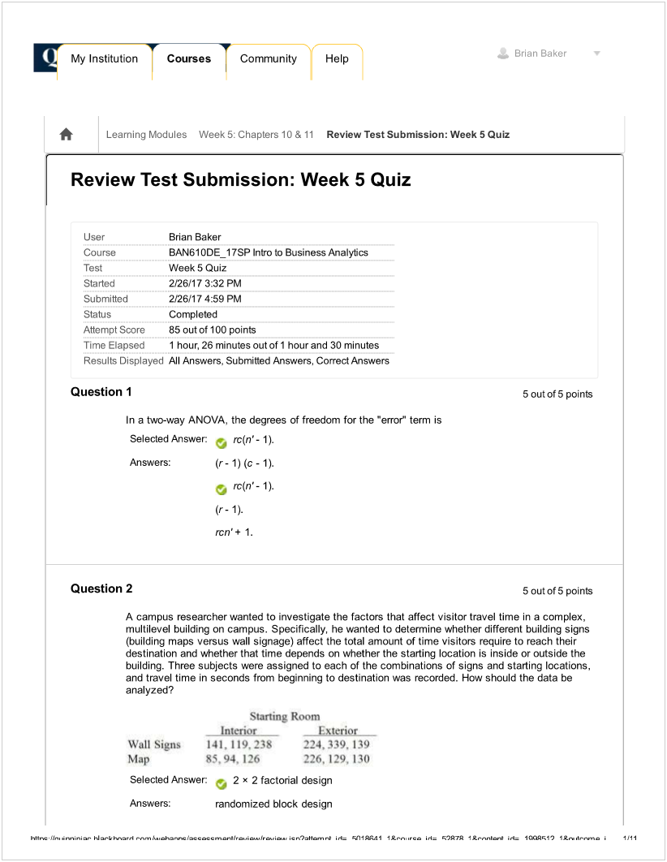

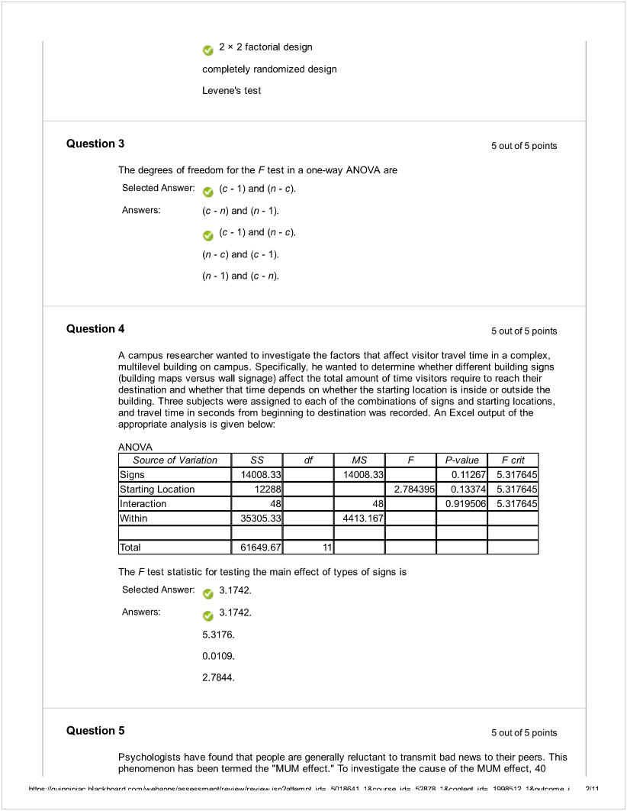

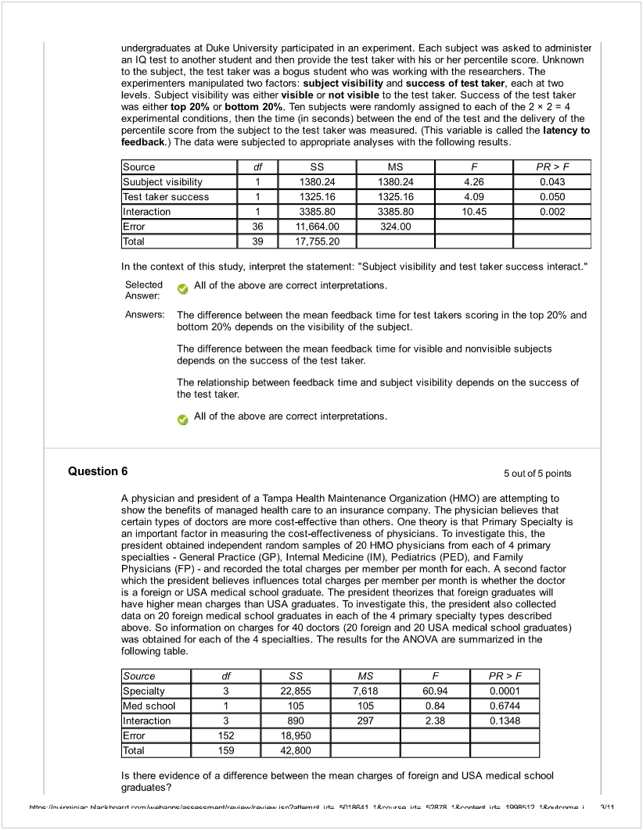

![Machine generated alternative text:
Selected
Answer: No, the test for the main effect for medical school is not significant at a = 0.10.
Answers: Maybe, but we need information on the 13-estimates to fully answer the question.
No, the test for the main effect for medical school is not significant at a = 0.10.
No, the test for the interaction is not significant at a = 0.10.
Yes, the test for the main effect for pflmary specialty is significant at a = 0.10.
Question 7 5outof5points
Psychologists have found that people are generally reluctant to transmit bad news to their peers. This
phenomenon has been termed the “MUM effect.” To investigate the cause of the MUM effect, 40
undergraduates at Duke University participated in an experiment. Each subject was asked to administer
an IQ test to another student and then provide the test taker with his or her percentile score. Unknown
to the subject, the test taker was a bogus student wio was working with the researchers. The
experimenters manipulated two factors: subject visibility and success of test taker, each at two
levels. Subject visibility was either visible or not visible to the test taker. Success of the test taker
was either top 20% or bottom 20%. Ten subjects were randomly assigned to each of the 2 x 2 4
experimental conditions, then the time (in seconds) between the end of the test and the delivery of the
percentile score from the subject to the test taker was measured. (This variable is called the latency to
feedback.) The data were subjected to appropriate analyses with the following results.
Source
df
SS
MS
F
PR>F
Suubject visibility
1
1380.24
1380.24
4,26
0.043
Test taker success
1
1325.16
1325.16
4,09
0.050
Interaction
1
3385.80
3385.80
10.45
0.002
Error
36
11,664.00
324.00
Total
39
17,755.20
At the 0.01 level, what conclusions can you reach from the analysis?
Selected
Answer: At the 0.01 level, there is evidence to indicate that subject visibility and test taker
success interact.
Answers: At the 0,01 level, the model is not useful for predicting latency to feedback.
L,:’
At the 0.01 level, there is evidence to indicate that subject visibility and test taker
success interact.
At the 0.01 level, there is no evidence of interaction between subject visibility and test
taker success.
At the 0.01 level, subject visibility and test taker success are significant predictors of
latency feedback.
Question 8 5 out of 5 points
An airline wants to select a computer software package foc its reservation system. Four software
packages (1, 2, 3, and 4) are commercially available. The airline will choose the package that
bumps as few passengers as possible during a month. An experiment is set up in which each
package is used to make reservations for 5 randomly selected weeks. (A total of 20 weeks was
h+qr,c 1k’.,  hi k kw’,,.’, “tm hnr,c íccocc, ,n  c,’),Kn, .‘ i,1 c(I1A I I  rc l Ç’)7q I *nnb I.’ I CìQI’ 1*,’,.  j AJI I](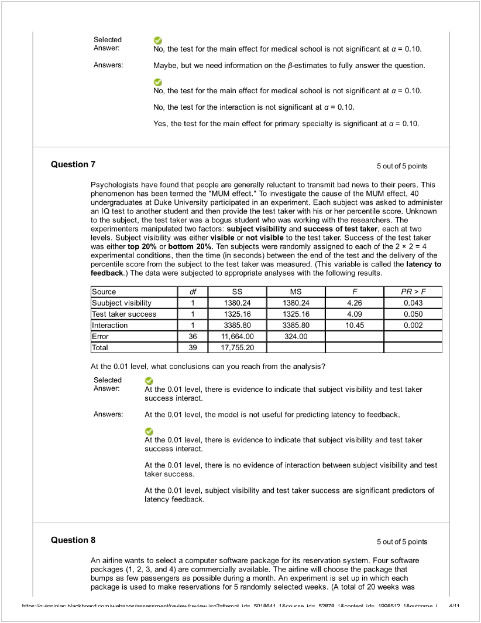)

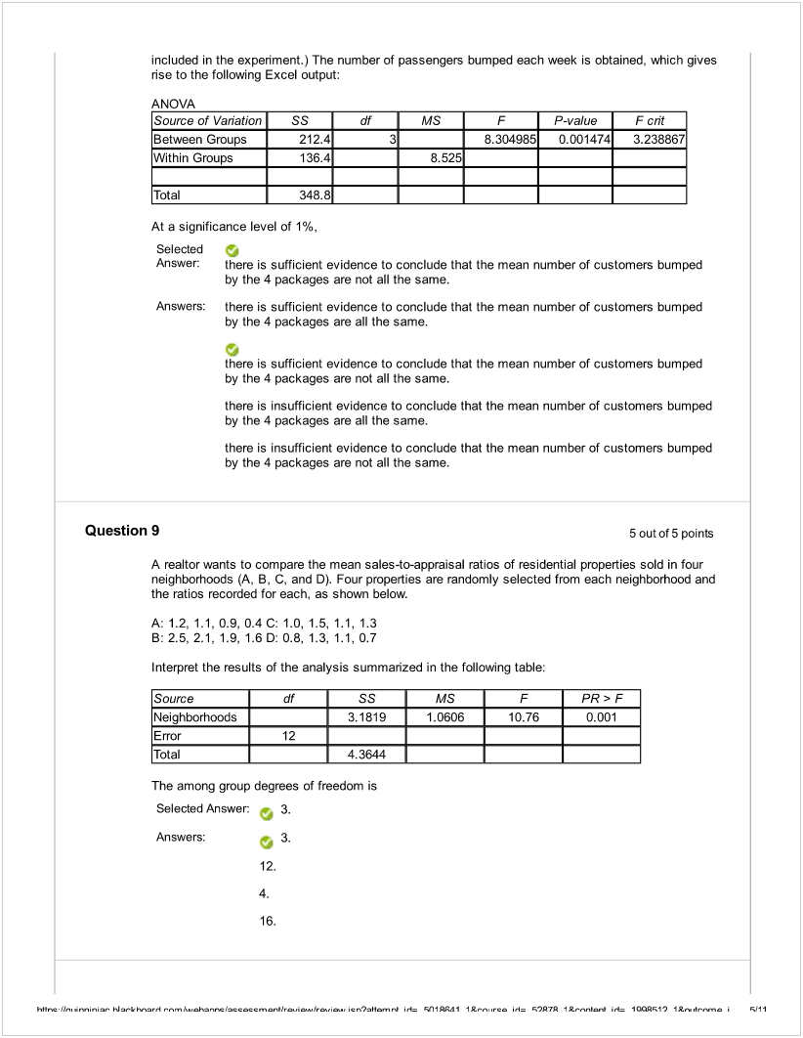

![Machine generated alternative text:
Question 10 5outof5points
A physician and president of a Tampa Health Maintenance Organization (HMO) are attempting to
show the benefits of managed health care to an insurance company. The physician believes that
certain types of doctors are more cost-effective than others. One theory is that Primary Specialty is
an important factor in measuring the cost-effectiveness of physicians. To investigate this, the
president obtained independent random samples of 20 HMO physicians from each of 4 primary
specialties - General Practice (GP), Internal Medicine (1M), Pediatrics (PED), and Family
Physicians (FP) - and recorded the total charges per member per month for each. A second factor
which the president believes influences total charges per member per month is whether the doctor
is a foreign or USA medical school graduate. The president theorizes that foreign graduates will
have higher mean charges than USA graduates. To investigate this, the president also collected
data on 20 foreign medical school graduates in each of the 4 primary specialty types descnbed
above. So information on charges for 40 doctors (20 foreign and 20 USA medical school graduates)
was obtained for each of the 4 specialties. The results for the ANOVA are summarized in the
following table.
Source
df
SS
MS
F
PR>F
Specialty
3
22855
7,618
60.94
0.0001
Med school
1
105
105
0.84
0.6744
InteractIon
3
890
297
2.38
0.1348
Error
152
18,950
Total
159
42,800
What degrees of freedom should be used to determine the critical value of the F ratio against which
to test for differences between the mean charges of foreign and USA medical school graduates?
Selected Answer , numerator df = 1, denominator df = 152
Answers: numerator df = 1, denominator df = 159
-. numerator df = 1, denominator df = 152
numerator df = 3, denominator df = 152
numerator rif = 3, denominator df = 159
Question li Ooutof5 points
A real estate company is interested in testing whether the mean time that families in Gotham have
been living in their current homes is less than families in Metropolis. Assume that the two
population variances are equal. A random sample of 100 families from Gotham and a random
sample of 150 families in Metropolis yield the following data on length of residence in current
homes.
Gotham: XG = 35 months, SG2 = 900 Metropolis: XM = 50 months, S,2 = 1050
Suppose a = 0.05. Which of the following represents the correct conclusion?
Selected O
Answer There is not enough evidence that the mean amount of time families in Gotham have
been living in their current homes is not less than families in Metropolis.
Answers:
There is enough evidence that the mean amount of time families in Gotham have been
living in their current homes is less than families in Metropolis.
There is not enough evidence that the mean amount of time families in Gotham have
been living in their current homes is not less than families in Metropolis.
h+$r,c Ik,  hi .-k h.nl  l..h2nr,c   nl i, c(I1A I I L. rc l  I *,‘,nlœ,I i’4 1OOÇ1) IL”,. .t,.nm. I R1 I](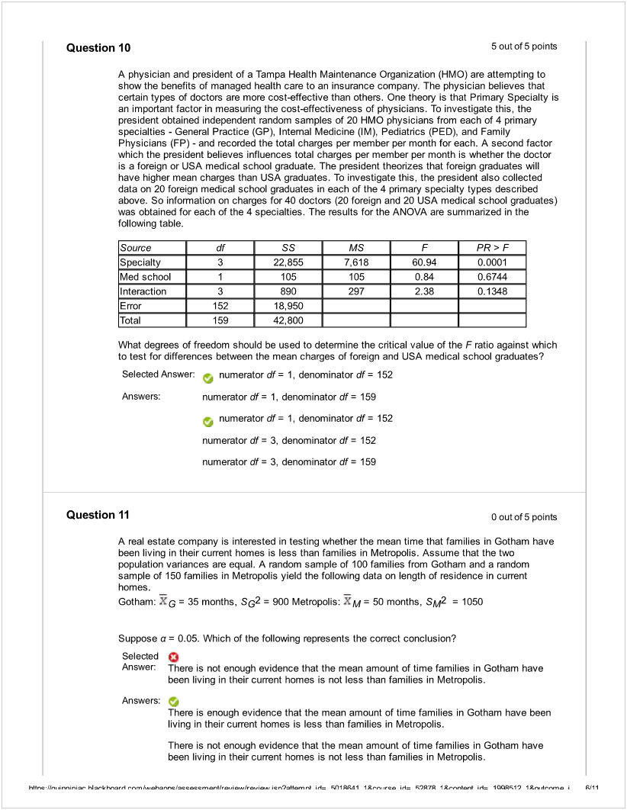)

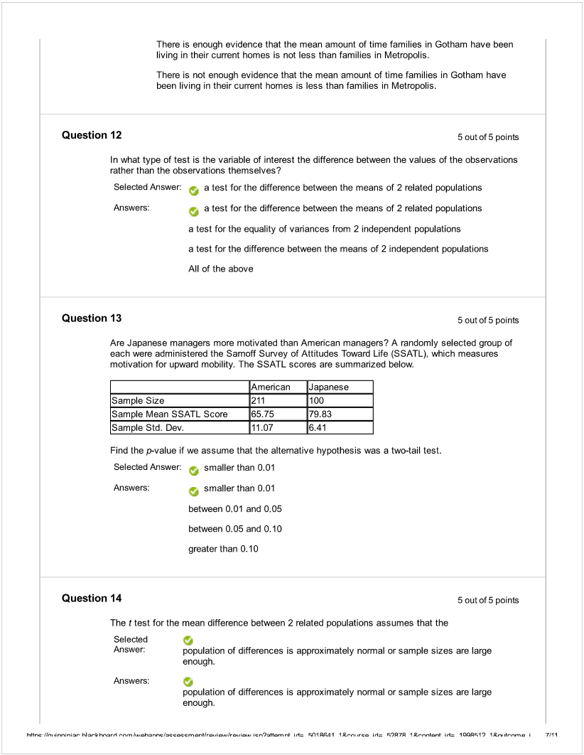

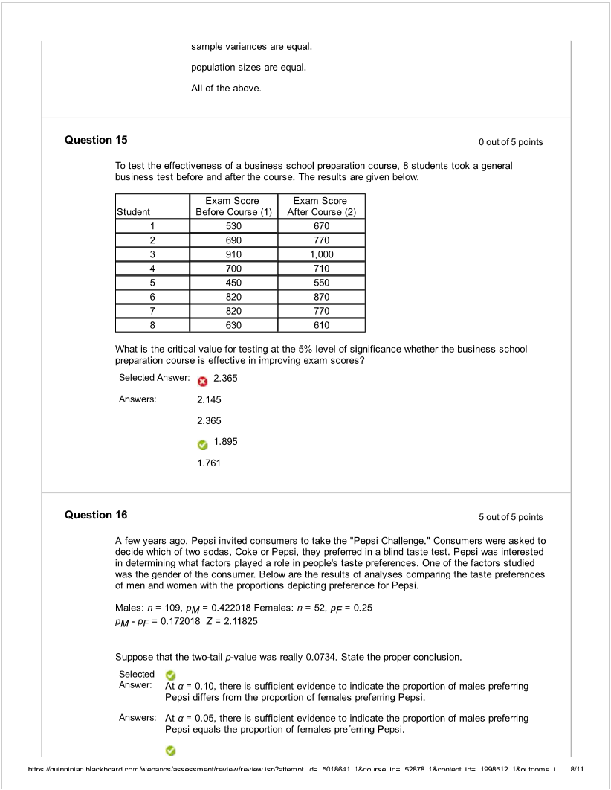

![Machine generated alternative text:
At a = 0.10. there is sufficient evidence to indicate the proportion of males preferring
Pepsi differs from the proportion of females preferring Pepsi.
At a = 0.08, there is insufficient evidence to indicate the proportion of males preferring
Pepsi differs from the proportion of females prefemng Pepsi.
At a = 0.05, there is sufficient evidence to indicate the pcoportion of males preferring
Pepsi differs from the proportion of females preferring Pepsi.
Question 17 Ooutof5points
The table below presents the summary statistics for the starting annual salaries (in thousands of
dollars) for individuals entering the public accounting and financial planning professions.
Sample I (public accounting): X1 = 60.35, S1 = 3.25, n = 12
Sample Il (financial planning): X2 = 58.20, S2 = 2.48, r = 14
Test wtiether the mean starting annual salaries for Individuals entering the public accounting
professions is higher than that of financial planning assuming that the two population variances are
the same.
Suppose a = 0.05. Which of the following represents the result of the test on a difference in the
vanances?
Selected Answer: o The null hypothesis is rejected.
Answers: The null hypothesis is not rejected.
The alternative hypothesis is rejected.
The null hypothesis is rejected.
Insufficient information exists on wtich to make a decision.
Question 18 5outof5poinls
A powerful women’s group has claimed that men and women differ in attitudes about sexual
discrimination. A group of 50 men (group 1) and 40 women (group 2) were asked if they thought
sexual discrimination is a problem in the United States. Of those sampled, 11 of the men and 19 of
the women did believe that sexual discrimination is a problem. Assuming W designates women’s
responses and M designates men’s, wiiich of the fdlowing are the appropriate null and alternative
hypotheses to test the group’s claim?
SelectedAnswer  H0: rIM-nw= Oversus H1: nM-rrWO
Answers: H0: 1’M - nw O versus H1: M - rrwO
H0: 1TM.1TW O versus H1: nM-Trw<0
H0: nM-nW0Oversus H1: UM-nw O
HO:nM-rrWOversusHl: UM-TTW>O
Question 19 5outof5points
h+Ik,,.r.nin. Ñ kh.,,,nl   cn),Kn,nb i, Ç(I1A1 1trc  Ç97 1L,nb i,4 1OQÇ1’) 1*r,..h.nm. I j11](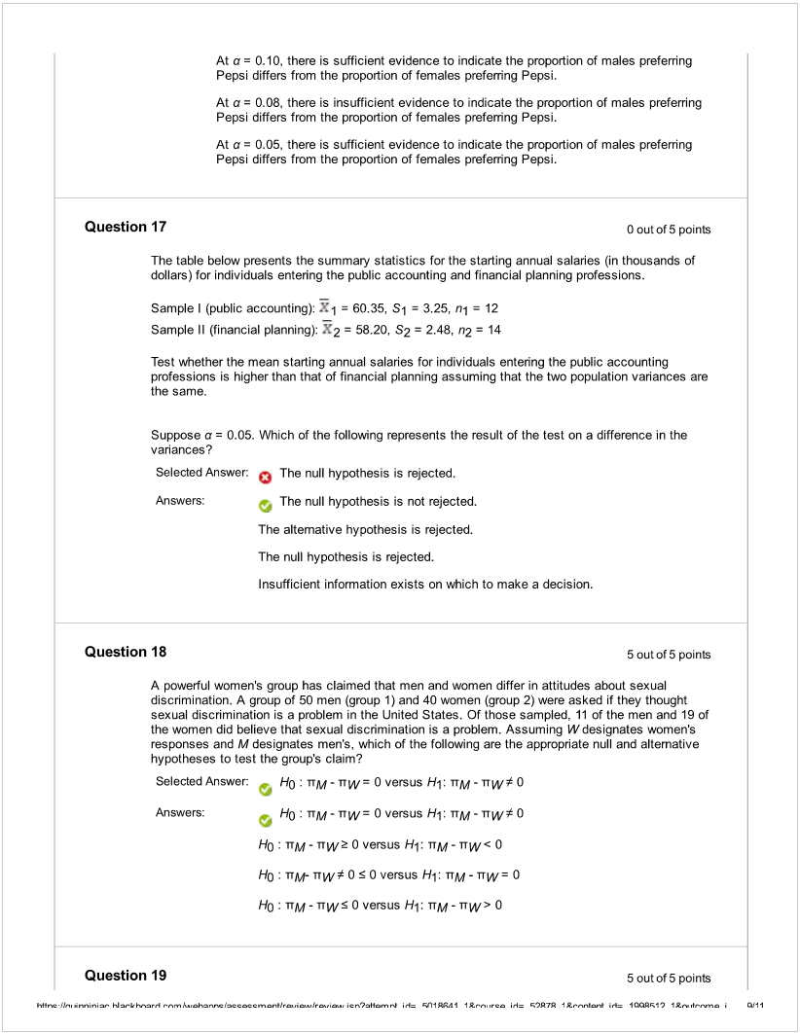)

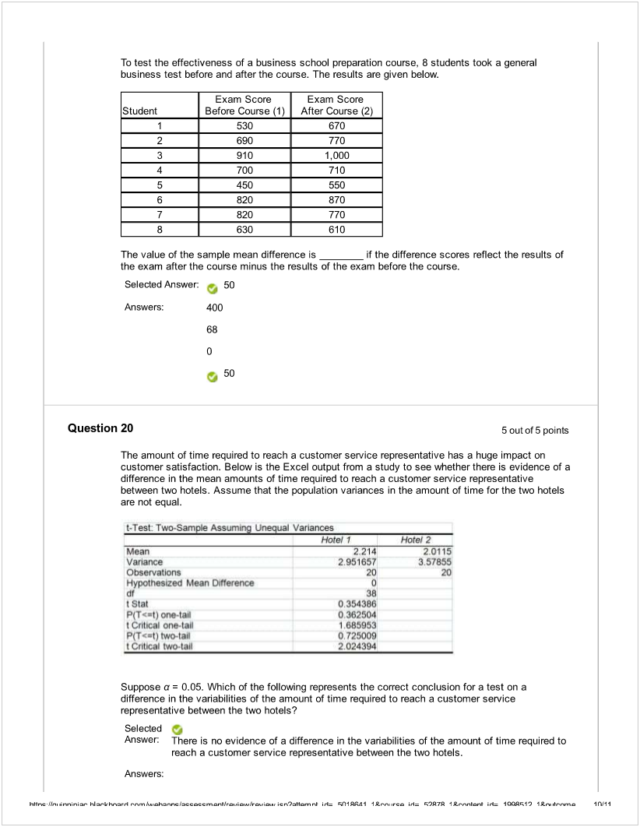

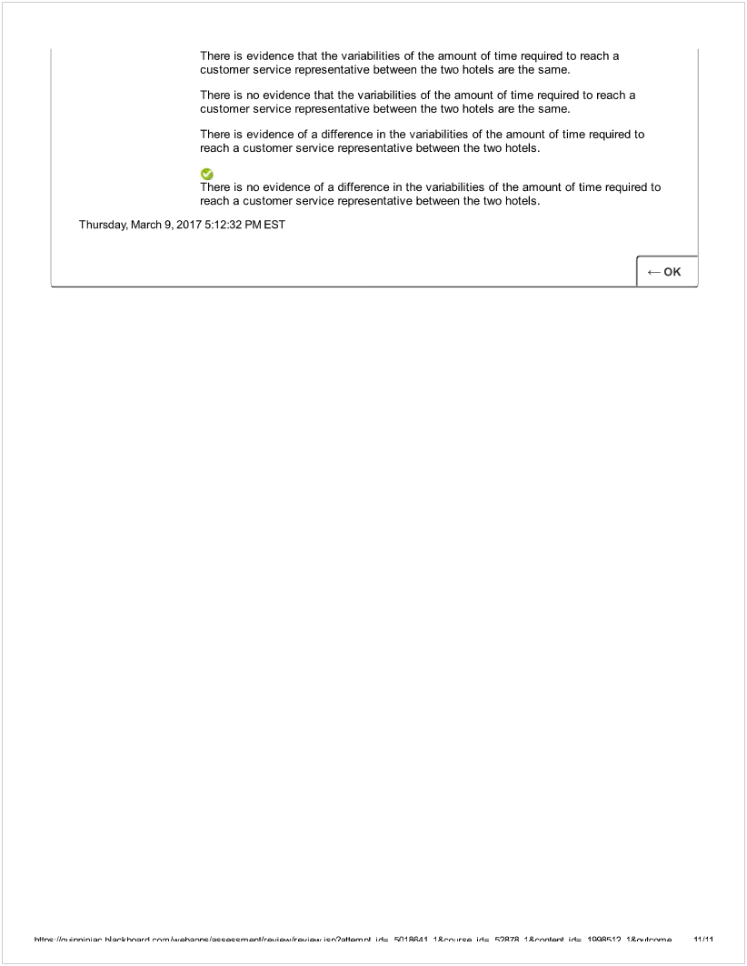

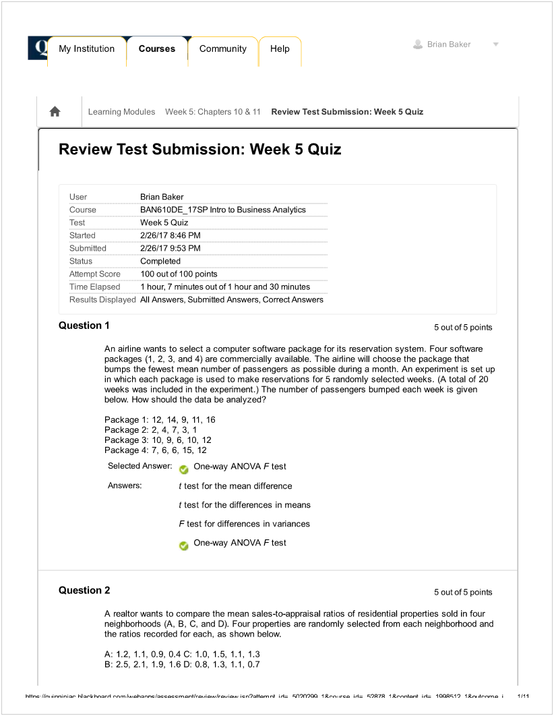

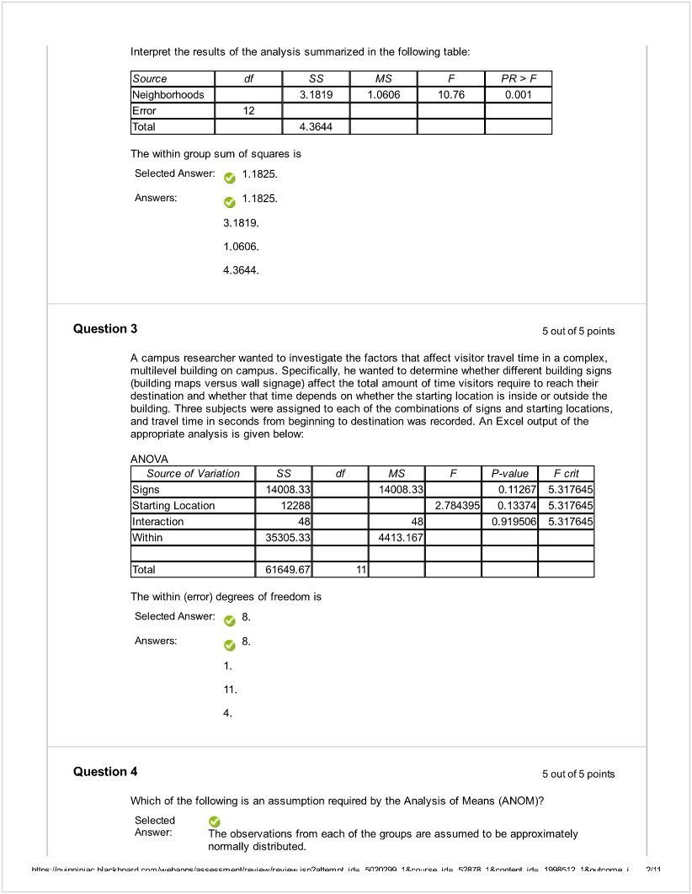

![Machine generated alternative text:
Answers:
The shape of the distribution of the observations from the groups is different.
The variance of the groups is different.
The number of observations in each group has to be at least 30.
The observations from each of the groups are assumed to be approximately
normally distributed.
Question 5
5 out of 5 points
An airline wants to select a computer software package for its reservation system. Four software
packages (1, 2, 3, and 4) are commercially available. The ai,line will choose the package that
bumps as few passengers as possible during a month. An experiment is set up in which each
package is used to make reservations for 5 randomly selected weeks. (A total of 20 weeks was
included In the experiment.) The number of passengers bumped each week Is obtained, which gives
rise to the following Excel output:
A NO VA
8.5251
tem is sufficient evidence to conclude that the mean number of customers bumped
by the 4 packages are not all the same.
Answers: there is insufficient evidence to conclude that the mean number of customers bumped
by the 4 packages are not all the same.
there is sufficient evidence to conclude that the mean number of customers bumped
by the 4 packages are not all the same.
there is insufficient evidence to conclude that the mean number of customers bumped
by the 4 packages are all the same.
there is sufficient evidence to conclude that the mean number of customers bumped
by the 4 packages are all the same.
Question 6
5 out of 5 points
An airline wants to select a computer software package for its reservation system. Four software
packages (1. 2. 3. and 4) are commercially available. The airline will choose the package that
bumps as few passengers as possible during a month. An experiment is set up in which each
package is used to make reservations for 5 randomly selected weeks. (A total of 20 weeks was
included in the experiment.) The number of passengers bumped each week is obtained, which gives
nse to the following Excel output:
ANO VA
Source of Vanation
SS df
MS F
P-value
F ct
Between Groups
212.4 3
8.304985
0.001474
3.238867
Source of Vanation
SS
df I— Pv&ue
t]  O.00t474
F cnt
Between Groups
212.4
3.238867
Within Groups
136.4
I I
Totaü
348.8
I_________
At a significance level of 1%,
Selected
Answer
h$r,r.nin. Ñ kkw,,n  cn9&4n,n i, ÇAflO trc l )7 1*,.nb .t4 1OOÇ1) 1*r..d,’,,n, I 2J11](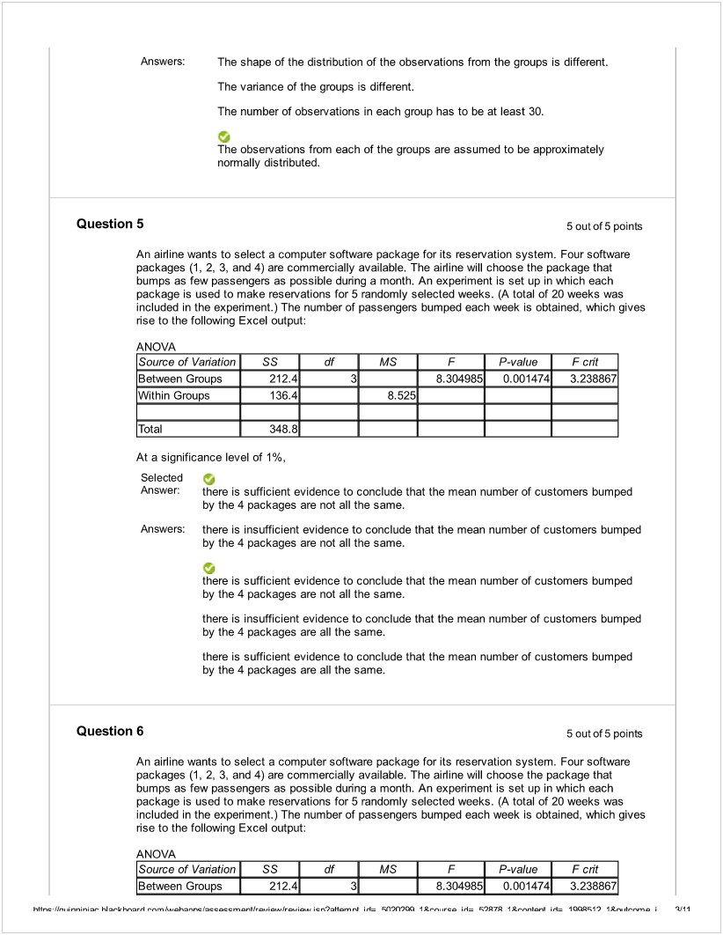)

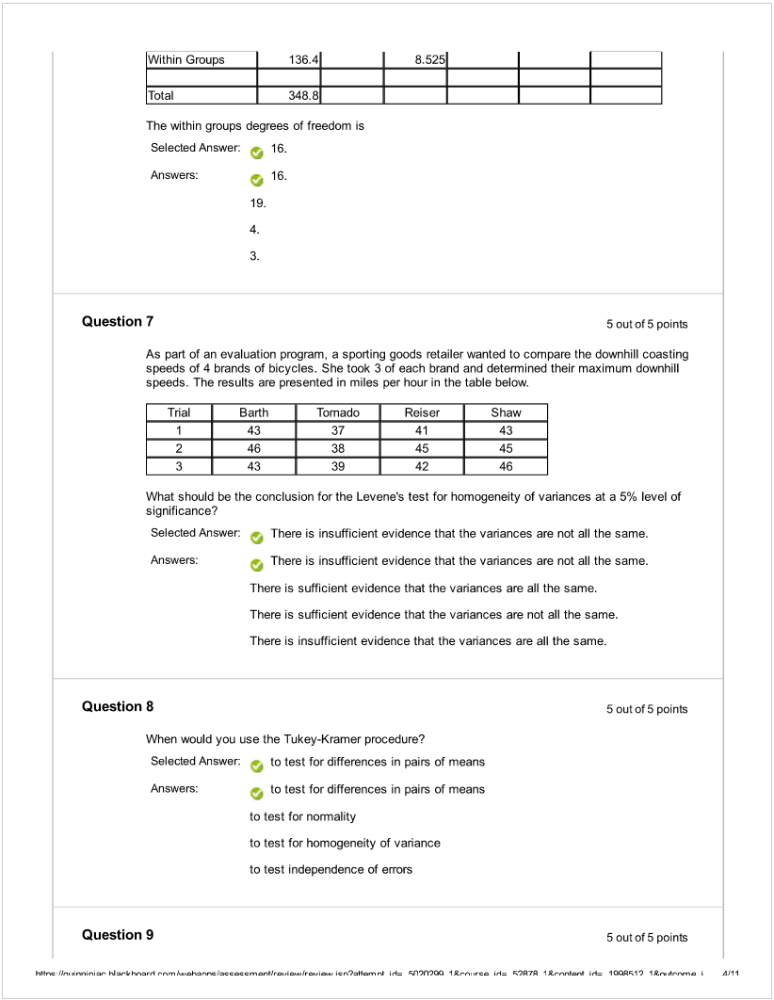

![Machine generated alternative text:
A campus researcher wanted to investigate the factors that affect visitor travel time in a complex.
multilevel building on campus. Specifically, he wanted to determine whether different building signs
(building maps versus wall signage) affect the total amount of time visitors require to reach (heir
destination and whether that time depends on wtiethe the starting location is inside or outside the
building. Three subjects were assigned to each of the combinations of signs and starting locations,
and travel time in seconds from beginning to destination was recorded. An Excel output of the
appropriate analysis is given below:
ANO VA
Source of Variation
SS
df
MS
F
P-value
F cnt
Signs
14008.33
1400833
0.11267
5.317645
Starting Location
12288
2.784395
0.13374
5.317645
Interaction
48
48
0.919506
5.317645
Within
35305.33
4413.167
Total
61649.67
11
The F test statistic for testing the interaction effect between the types of signs and the starting
location is
Selected Answer 0.0109.
Answers:
0.0109.
5.3176.
2.7844.
3. 1742.
Question 10
5 outof 5 points
A campus researcher wanted to investigate the factors that affect visitor travel time in a complex.
multilevel building on campus. SpecÍficaIy, he wanted to determine whether different building signs
(building maps versus wall signage) affect the total amount of time visitors require to reach their
destination and whether that time depends on whether the starting location is inside or outside the
building. Three subjects were assigned to each of the combinations of signs and starting locations,
and travel time in seconds from beginning to destination was recorded. An Excel output of the
appropriate analysis is given below:
ANOVA
Source of Variation
SS
df
MS
F
P-value
F cnt
Signs
14008.33
14008.33
0.11267
5.317645
Starting Location
12288
2.784395
0.13374
5.317645
Interaction
48
48
0.919506
5.317645
Within
35305.33
4413.167
Total
6164967
11
At 10% level of significance,
Selected
Answer: there is insufficient evidence to conclude that the difference between the mean traveling
time for the different types of signs depends on the starting locations.
Answers: -:
there is insufficient evidence to conclude that the difference between the mean traveling
time for the different types of signs depends on the starting locations.
h$rcIk, 
c,),Kn,nb i, ÇtIfl,OO tt,- rc l 97fi 1*,,nb i.4 1Ç1) 1*roh-,.n, I ÇJII](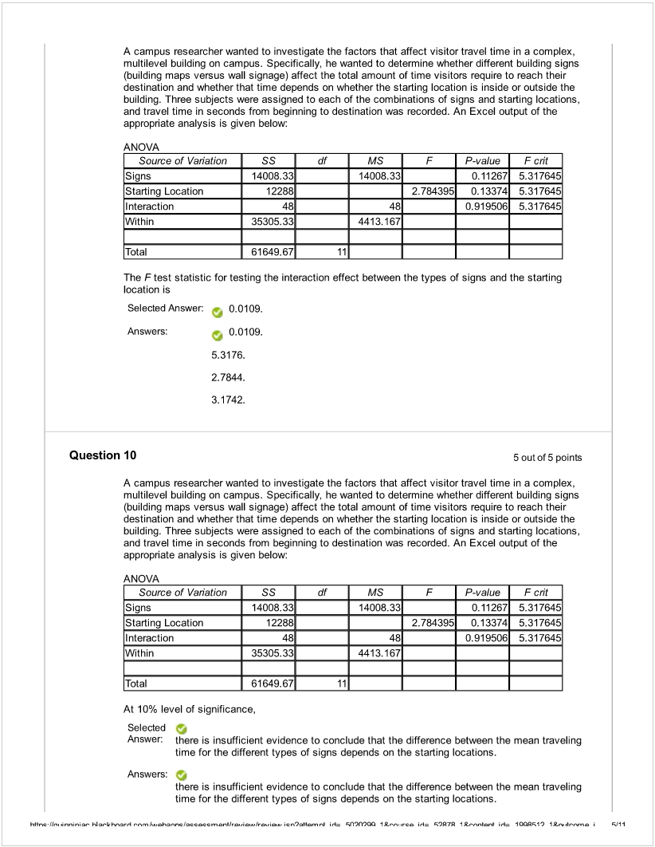)

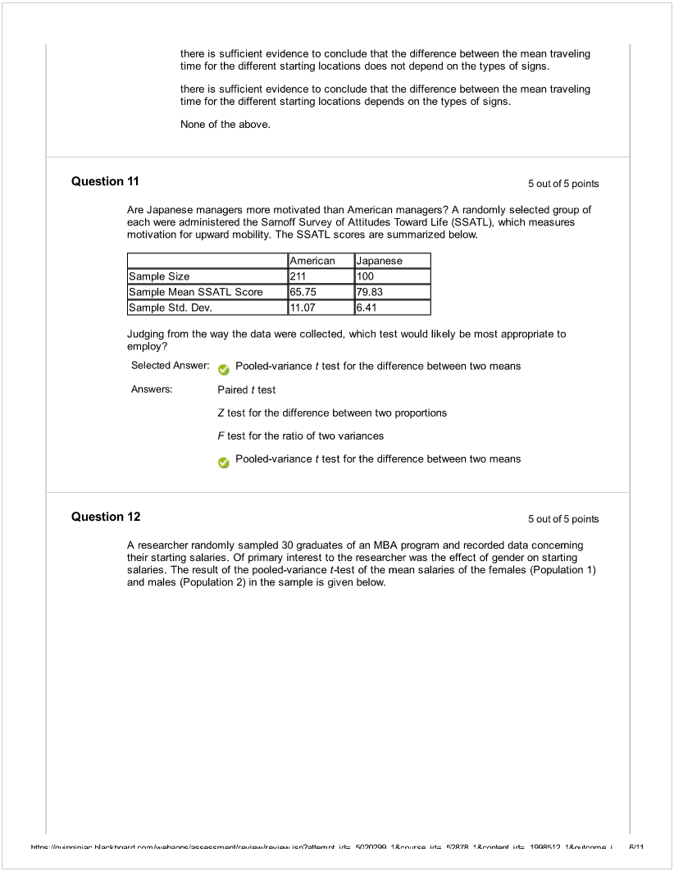

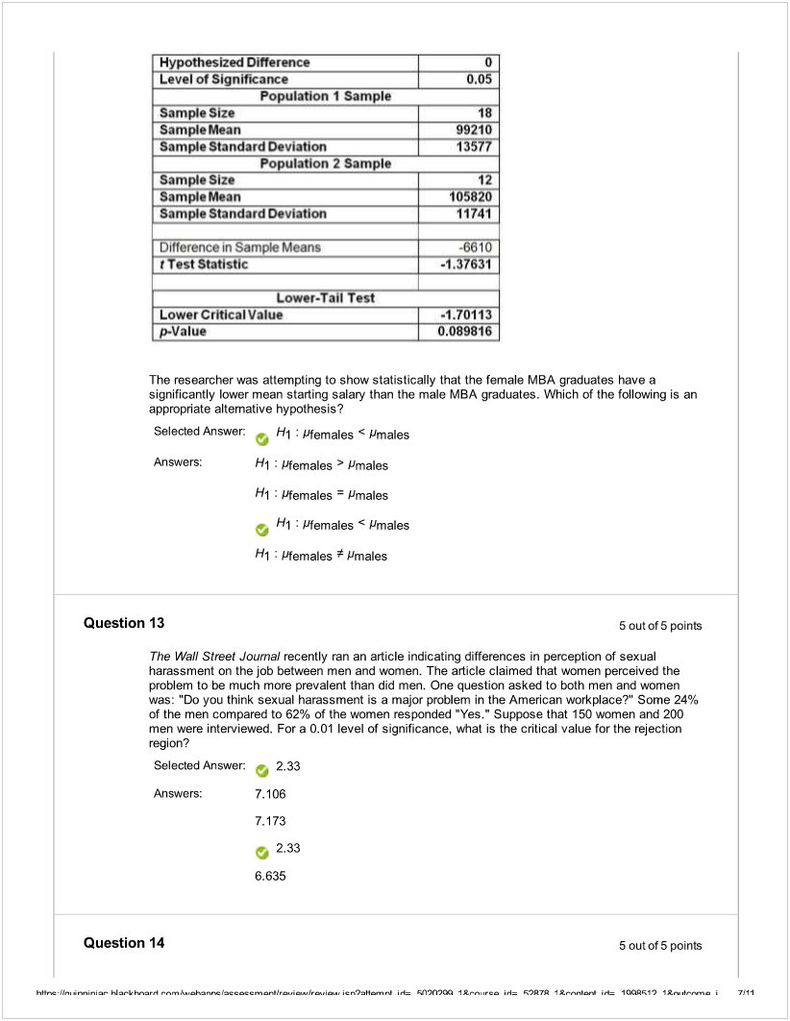

![Machine generated alternative text:
The amount of time required to reach a customer service representative has a huge impact on
customer satisfaction. Below is the Excel output from a study to see whether there is evidence of a
difference in the mean amounts of time required to reach a customer service representative
between two hotels. Assume that the population vanances in the amount of time for the two hotels
are not equal.
t-Test Two-Samp4e Assuming
Unequ Va4-Iances
Hot
eli
Hotel2
Mean
2.214
2.01 15
VarIance
2,951657
3.57855
Observations
20
20
Hypothesized Mean Difference
O
df
38
t Stat
0 354386
P(Tc.t)on.-taN
0362504
t Critc.al one-tad
1 885953
P(T’.t) two-tail
0725009
t Cntical two-tail
2.024394
Suppose a = 0.05. Which of the following represents the result of the relevant hypothesis test?
Selected Answer - The null hypothesis is not rejected.
Answers: The null hypothesis is not rejected.
The alternative hypothesis is rejected.
The null hypothesis is rejected.
Insufficient information exists on which to make a decision.
Question 15 5outof5 points
The table below presents the summary statistics foc the starting annual salaries (in thousands of
dollars) for individuals entering the public accounting and financial planning professions.
Sample I (public accounting): X1 = 60.35, S1 = 3.25, n = 12
Sample Il (financial planning): X2 = 58.20, S2 = 2.48, 2 = 14
Test whether the mean starting annual salaries for individuals entering the public accounting
professions is higher than that of financial planning assuming that the two population variances are
the same.
Suppose a = 0.05. Which of the following represents the correct conclusion for a test on a
difference in the variances?
Selected Answer There is no evidence of a difference in the variances.
Answers: There is no evidence that the variances are the same.
There is evidence of a difference in the vaflances.
There is evidence that variances are the same.
, There is no evidence of a difference in the variances.
Question 16 5outof5points
h+$r,c 1k,,  hi .-k h.-,nl --m l..h2nr,c cccml   nl i, Ç41fl ‘I rc l 97fi I *,,,nlœ,I i4 I OO1) IL.,. ,lnnn, I RJI I](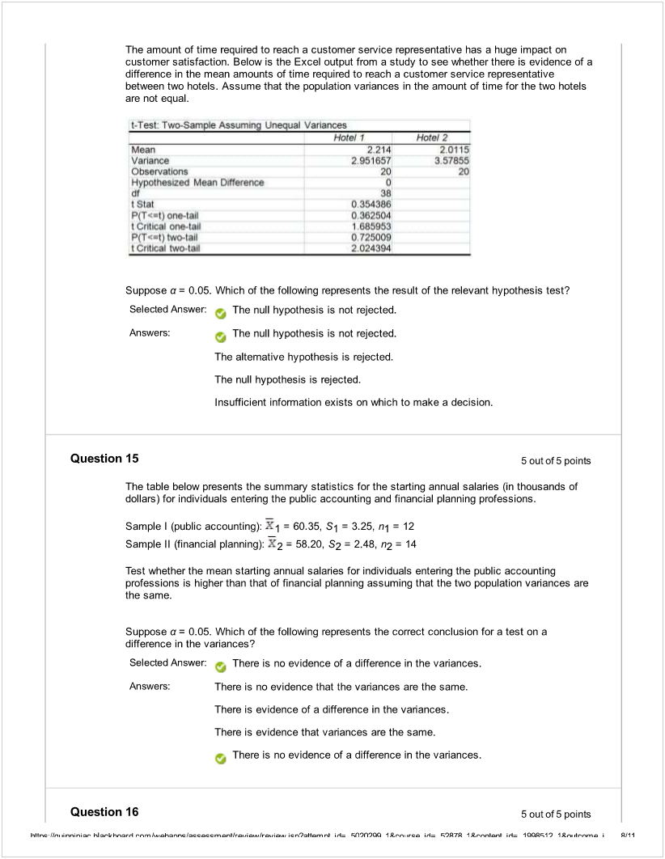)

![Machine generated alternative text:
A real estate company is interested in testing whether the mean time that families in Gotham have
been living in their current homes is less than families in Metropolis. Assume that the two
population variances are equal. A random sample of 100 families from Gotham and a random
sample of 150 families in Metropolis yield the following data on length of residence in current
homes.
Gotham: XG = 35 months, SG2 = 900 Metropolis: XM = 50 months, Sp.g2 = 1050
Suppose a = 0.05. Which of the following represents the correct conclusion?
Selected 
Answer: There is enough evidence that the mean amount of time families in Gotham have been
living in their current homes is less than families in Metropolis.
Answers: There is enough evidence that the mean amount of time families in Gotham have been
living In their current homes is not less than families in Metropolis.
J
There is enough evidence that the mean amount of time familles In Goiham have been
living in their current homes is less than families in Metropolis.
There is not enough evidence that the mean amount of time families in Gotham have
been living In their current homes is not less than families In Metropolis.
There is not enough evidence that the mean amount of time families in Gotham have
been living in their current homes is less than families in Metropolis.
Question 17 5outof5points
A quality control engineer is in charge of the manufacture of USB flash drives. Two different
processes can be used to manufacture the flash drives. He suspects that the Kohler method
produces a greater proportion of defects than the Russell method. He samples 150 of the Kohler
and 200 of the Russell flash drives and finds that 27 and 18 of them, respectively, are defective. If
Kohler is designated as “Group 1” and Russell is designated as “Group 2.” perform the appropriate
test at a level of significance of 0.01.
The hypotheses that should be tested are
SelectedAnswer H0:n1 -u2OversusHl :nl -n2>0.
Answers: H0: 1 -n2Oversus H1 :ui -TT2>0.
HO:nl-w2OversusHl :TT1-TT20.
H0: “1 -1T2OversusHl :  U2<0.
H0: “1 -TT2=OversusHl : ni fl20.
Question 18 5outof5points
To test the effectiveness of a business school preparation course, 8 students took a general
business test before and after the course. The results are given b&ow.
Exam
Score
Exam
Score
Student Before C
ourse (1)
After C
ourse (2)
h+$r.c 1k,,  hi .-k h.nl  l..h2nr,c cccml   nl i, ÇtIfl,OO  rc l 97fi I *,‘,nlœ,I i4 1OOÇ1’) IL.,.. .t,.nm. I  I](

